March 27th, 2026 Issue #243 The Iris The Bodhi Glyphix Studio

Greetings!

Are you feeling a bit heavy~ Body, Mind & Soul? The long hard winter and lack of sunshine can cause lethargy and depression. Our Root Chakra misses being connected to the earth~ as for most of us have been experienced heaviness or even depression. Or perhaps you are a bit anxious from the solar flares ups, mercury being retrograde and the energy of the spring equinox. With the transition of Spring and reconnecting to the revitalization of our energy through the flow of Shatki (from the composting of winter in the new cycle), that dormant energy that sits at the base of our spines (kundalini) rises. Practicing Yoga awakens this sleepiness in our body, mind & souls. Our Yoga Class schedule is at the bottom of the newsletter. Check it out and please try a class, or two or three. Perhaps you would like to try a class in the comfort of your home. Rose has a YouTube Channel, pay $15 and save gas and your time traveling here! Go to www.youtube@roseczyrny

We hope you enjoy our newsletters! Should you wish not to receive these electronic newsletters- you always have an opt out option by clicking the link at the bottom of this newsletter…
_______________________________________________________________________________________
Our Studio is closed April 8th through April 25th
Our Rose will be Having surgery On April 9th. Should you need any supplements or have any questions or concerns? Please reach out to us before so we can take care of your wants and your needs. Rose is having a total hip replacement of her right hip. If you’ve been reading our messages the past few months- You have heard that she was in and out of hospitals over the holidays. She was misdiagnosed and told by Mercy Hospital that she needed extensive surgery on her spine which would have kept her out for at least a year. Thankfully, her cousin Jim Czyrny Who is head of Buffalo Orthopedics advised her to Seek the help of Dr Kowalski a top neurosurgeon in Western New York. Together, her cousin and Dr Kowalski had found that it wasn’t her back that needed the surgery, it was her right hip. She was misdiagnosed by Mercy Hospital. The reason for the fractures and structural problems is this- After years of having an acidic PH, the body is wise and it’ll pull Calcium out of the bones to buffer the acidic PH. This created a weakness in her spine and her hips. She had fractured T12 vertebrae and a few toes on her feet during the summer last year. She’s been very busy taking care of the world and neglecting herself. If you have a punch card and you’re concerned that it’s expiring, all punch cards will be extended without an expire date. If you are interested in her yoga classes online, please read the above paragraph and enjoy yoga from the comfort from your home. Rose has a YouTube channel with over 40 videos. There’s a Paypal link to pay $15 per class, or if you have a punch card, just remember to punch your card for each class that you took online. We are looking forward to seeing you again. Prayer warriors, please keep sending positive thoughts and prayers.

______________________________________________________________________________________
Fulvic Acid
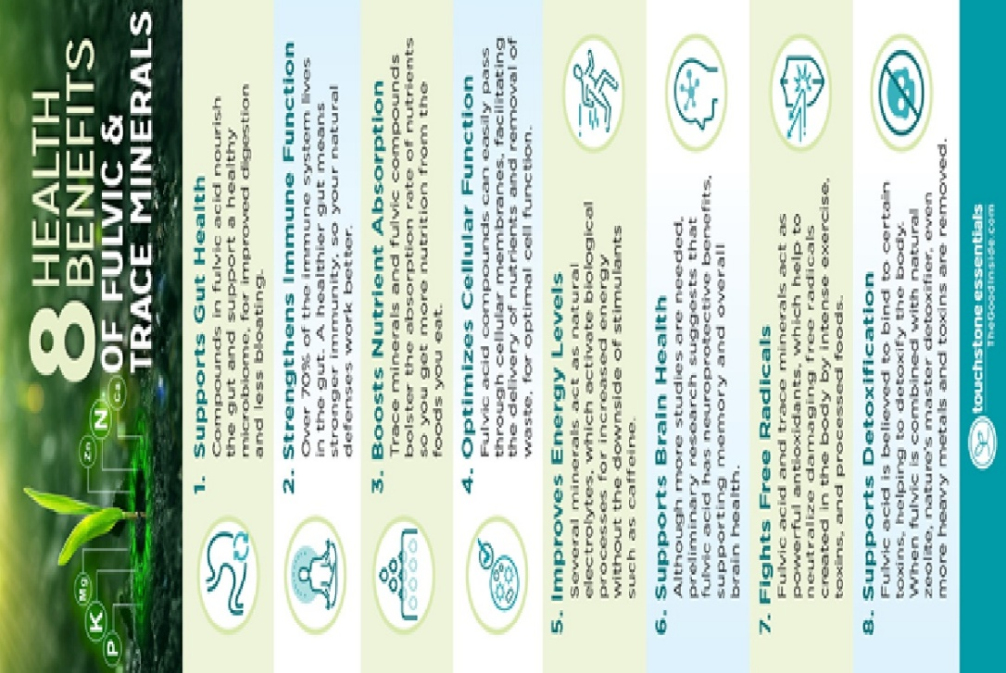
8 Health Benefits of Fulvic Acid
While it’s long been used in alternative health, fulvic acid has recently achieved greater awareness among mainstream natural health enthusiasts, thanks to growing scientific recognition of its benefits for the gut microbiome, immune system, antioxidant potential and more.
But if you haven’t heard of it before, you might be wondering what exactly is fulvic acid, and what are the health benefits you can expect from adding fulvic acid to your daily routine. This article explains everything you need to know.
What is fulvic acid?
Formed over a long period of time through the breakdown of nutrient-rich plant matter, fulvic acid contains complex organic substances that cannot be replicated in a lab.
Research shows that fulvic acid contains a complex mix of nutrients including amino acids, minerals, nucleic acids, vitamins, and phytochemical compounds. Most of these nutrients are in ionic form which increases their bioavailability.
Fulvic acid can be found in healthy soils, compost, marine sediments, and especially in peat bogs which contain deposits of concentrated plant matter.
Why do we need fulvic acid?
While root vegetables such as radishes and parsnips contain some fulvic acid, decades of conventional farming methods mean most soils are lacking in organic plant matter, resulting in food that is depleted of fulvic acid and the trace minerals we need to thrive.
How bad is it? A landmark study published in the Journal of the American College of Nutrition evaluated 43 garden crops for nutritional values in 1950 and 1999, finding significant declines for many nutrients including calcium, potassium, iron, and vitamin C.
While food companies try to counteract this shortfall by “enriching” the food, they use synthetic vitamins, which don’t deliver the same benefits as organic plant-based nutrients.
That’s why it’s not surprising that studies show 90 percent of people are deficient in one or more minerals that are essential for good health. For the same reason, we’re simply not getting much fulvic acid from our food today.
What are the health benefits of fulvic acid?
Fulvic acid is a nutrient booster that has fulvic compounds and trace minerals known to support every system in the body, working at a foundational level to improve how our cells function. Here are eight benefits of fulvic acid and trace minerals to support health.
1. Supports Gut Health
Compounds in fulvic acid nourish the gut and support a healthy microbiome, for improved digestion and less bloating. Minerals such as potassium and magnesium are essential for normal digestive function, helping to relax and contract muscles that move food efficiently through the digestive tract.
2. Strengthens Immune Function
Over 70% of the immune system lives in the gut. A healthier gut means stronger immunity, so your natural defenses work better. Fulvic acid also shows immune modulator effects, helping to balance immune system function when it is either too active or too weak.
3. Boosts Nutrient Absorption
Trace minerals and fulvic compounds bolster the absorption rate of nutrients so you get more nutrition from the foods you eat. Minerals also play a critical role as cofactors in the use of nutrients in the body.
4. Optimizes Cellular Function
Fulvic acid compounds can easily pass through cellular membranes, facilitating the delivery of nutrients and removal of waste, for optimal cell function. Minerals are also essential for the messaging of nerve impulses throughout the body.
5. Improves Energy Levels
Several minerals act as natural electrolytes, which activate biological processes for increased energy without the downside of stimulants such as caffeine. This provides a more natural, sustained energy throughout the day.
6. Supports Brain Health
Although more studies are needed, preliminary research suggests that fulvic acid has neuroprotective benefits, supporting memory and overall brain health. Additionally, macro and trace minerals are essential for healthy brain development and function.
7. Fights Free Radicals
Research shows fulvic acid and trace minerals act as powerful antioxidants, which help to neutralize damaging free radicals created in the body by intense exercise, toxins, and processed foods. One study on fish showed that fulvic acid supplementation resulted in significantly increased antioxidant activity.
8. Supports Detoxification
Fulvic acid is believed to bind to certain toxins, helping to detoxify the body. When fulvic is combined with natural zeolite, nature’s master detoxifier, even more heavy metals and toxins are removed.
Given the wide range of health benefits, and the lack of fulvic acid in most food today, supplementing with fulvic acid is the best way to get more of this natural compound.
What about Shilajit for fulvic acid?
Traditionally found in the Himalayas, shilajit has been used for centuries in Ayurvedic medicine to restore health and vitality. Shilajit contains both fulvic acid and humic acid.
However, many sources of ayurvedic supplements (including shilajit) have been found to contain toxic heavy metals, especially lead. This may be due to the fact some humic acid deposits have higher concentrations of heavy metals.
Since studies attribute the health benefits of shilajit to its fulvic acid content, it’s better to choose a supplement without humic acid, and to make sure that the fulvic acid has been tested and affirmed to be low in heavy metals.
What to look for in a fulvic acid supplement
It’s important to know the sourcing of the fulvic acid, since some fulvic acids are extracted from brown coal (lignite). Look for fulvic acid extracted from plant sources such as peat bogs, and confirm the product is tested for heavy metals to ensure it is free of toxins.
While fulvic acid includes some minerals, look for a supplement that includes added plant-based minerals to optimize micronutrient support, energy levels and cellular health. And since fulvic acid supports detoxification, a supplement that includes natural zeolite is a powerful way to enhance the removal of toxins and heavy metals from the body.
The Bottom Line
Conventional farming methods including pesticides, herbicides, and chemical fertilizers have depleted the soil our food grows in, resulting in crops that look the same but are empty of the nutrients we need to look and feel our best.
As a result, soils are missing fulvic acid, which means that most of us just don’t get enough of the fulvic compounds, trace minerals, and antioxidants we need. Today, scientists, nutritionists, and other health experts recognize the benefits of fulvic acid to support the gut, immune system, and overall health.

__________________________________________________________________________________________________________________________

______________________________________________________________________________________
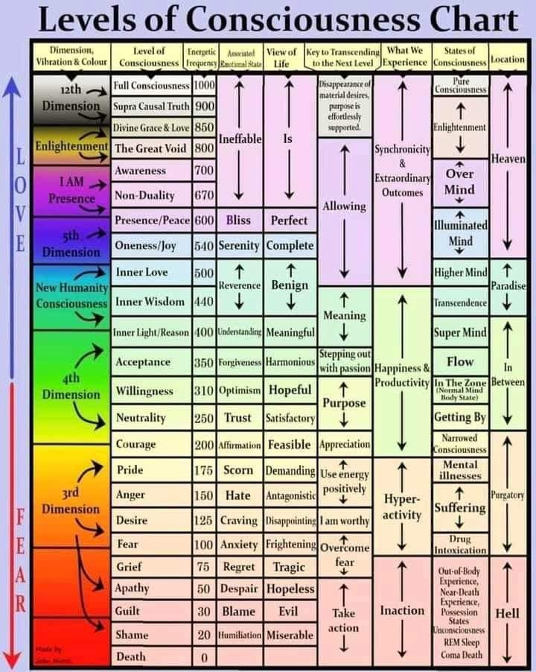
Map of Scale of Consciousness
The map of consciousness is a calibrated list of the human spectrum of available consciousness levels - your spiritual numbers. The map provides a way to align with higher states, enabling greater happiness, freedom, and the ability to effect change. It is the first and, to my knowledge, the only calibration of consciousness. David Hawkins MD/PHD wrote the book Power vs. Force and explained the MOSC Map of Scale of Consciousness in great detail.
During Body, Mind & Soul Consultations I can let you know where you're calibrating at. Understand that your level may change with difficulties and challenges in your life. They can go up or they can go down. It is said levels under 200 are false, lack integrity and do not support life. Levels over 200 have truth, integrity and support life. During the harmonic convergence in 1987 it is said that the majority of our planet's population had tipped over the 200 mark. This was a positive sign that we were moving into the age of light- its called the Kali Yugas. It is said we are moving swiftly into it- with the eclipses and all of the solar flare ups- they are helping us ascend. Exciting times! Positive changes are coming!

______________________________________________________________________________________
"IF YOU HAVE A DOG, READ THIS YOU WILL LOVE IT.
Did you know that your dog has come with a spiritual mission to support you in the most difficult moments of your life?
Dogs are emotional therapists, they would never hesitate to approach you, lick you and accompany you if you feel bad. Your mission may be dedicated to a single person or to an entire group. Many do impressive work with one person or can impact an entire group of people such as a family.
♥ They are energy protectors
♥ They are protective angels that absorb vibrations of imbalance from both you and the places you live in. ♥ They are then purged with water, plants and other elements. They sacrifice themselves for you when there are bad energies that can affect you.
♥ They know what their mission is and do not hesitate to protect you from anything. Some sudden deaths or illnesses are due to those strong energies they absorb.
♥ A good way to purge that bad energy is by giving them a lot of love.
♥ They choose you. Even when you have the opportunity to “choose” among many puppies, he will approach you and gain your trust and affection so that you select him. And you will know that you have chosen well, but it was not you who chose.
♥They are sensitive to vibrations of all kinds
♥ They are connected to very high vibrations and are incredibly sensitive. They are capable of perceiving everything, they are energy radars, they are always alert even when you see them resting. They have impressive hearing sensitivity, as well as their sense of smell and vision. They can see through dimensions and planes that people cannot perceive.
♥ They are the perfect emotional therapists
♥ They will always be attentive, they ensure that everything is always in harmony. When they feel sadness, depression, heartbreak or any negative feeling, they look for a way to improve their mood. The movement of its tail emits vibrational waves that harmonize the environment. They are signs of love.
♥ Dogs are the best friends, the best life companions; They are playful and innocent, they are simply angels that go on all fours, brightening your life.

Yoga Nidra Meditation
Discover Your animal totem

Have you ever wondered what your animal totem is?? Please join me for a very special yoga meditation class called Yoga Nidra. This is not your typical mediation~ YN opens up doorways, releases blockages, it heals every organ, bone, muscle etc, it goes DEEP in to ALL levels of consciousness, releasing scars from traumas & abuses we have suffered from in this lifetime and more. Your YN takes you through the veils of life, afterlife, and previous lifetimes. We experience time travel, astro projection and it's also trippy! YN has an emphasis on health and healing where habitual thinking and thought patterns are reduced or eliminated. It also helps with insomnia and stress reduction and brings an incredible calmness, quietness, clarity and is one of the deepest of all meditations.
Yoga Nidra means Yogic Sleep and is a state of conscious Deep Sleep. In this Meditation, you remain in the Waking state of consciousness, and gently focus the mind, while allowing thought patterns, emotions, sensations, and images to arise and go on. However, in this meditation, you leave the Waking state, go past the Dreaming state, and go to Deep Sleep, yet remain awake. While Yoga Nidra is a state that is very relaxing, it is also used by Yogis to purify the Samskaras (negative energy & thought patterns). It’s also great for insomniacs and those who suffer with PTSD, as well as a powerful tool for manifesting. You will have the best sleep Wednesday night!!

The class is being held Monday, April 6th at 7:00 PM~ we hold our Yoga Nidra Meditation the first Monday of the month. The fee is $15, pre-registration is a must. To pre-pay & register safely http://www.bodyglyphix.com/upcomingclassesevents.html~ paying on line is $17 to cover our processing costs.

_______________________________________________________________________________________
SPRING YOGA SCHEDULE
Times | Mon | Tue | Wed | Thu | Fri
9:30 am | Mystical  Vinyasa  Flow |  | Gentle  Healing  Yoga |  | Mystical Vinyasa  Flow
6:10 pm |  | Mystical  Vinyasa  Flow |  | Mystical  Vinyasa  Flow

Mystical Vinyasa Flow A nice blend of Hatha & Integrative Yoga, Pilates, Somatics, fused with Reiki, blended with the wisdom of the cosmos & mysticism of Gaia ~ geared to participants needs.
Gentle Healing Yoga Gentle, healing Yoga- Yoga Therapy, Somatics and Energy Medicine Yoga fused with Reiki, blended with blended with the wisdom of the cosmos & mysticism of Gaia ~ geared to participants needs.
Yoga Nidra The deepest- most healing meditation on the planet- the 1st Monday of the month at 7:30 PM
Life Goes Om Free Yoga Classes to anyone with Cancer or a life threatening disease
Class Prices $15 drop in fee or punch card fees- 8 classes $95 or 16 classes for $165
Yoga for Sports Yoga for Golfers, Runners or Snow- Sports $100 per hour
Yoga Therapy, Chakra Toning or Private Yoga by appointment $100 per hour (click here for directions)

"Wishing you Heaven in your heart, starlight in your soul and miracles in your life in these changing times" The vibrational rate of our planet is quickening- the vibrations have a dominant masculine force.
Yoga and meditation are very helpful with this transition….
The Bodhi Glyphix Studio
Rose Czyrny
12377 Big Tree Road, East Aurora, NY 14052
email: bodyglyp@msn.com
website: www.bodyglyphix.com
phone: 716.652.7805

