September 27, 2025 Issue #237 The Iris The Bodhi Glyphix Studio

Greetings!

The nights grow longer, and our days grow shorter. You may find yourself feeling heavier than usual- that's typical this time of year. Our bodies yearn for root vegetables such as potatoes, beets, carrots, onions, garlic, etc. We are drawn towards the earth and root vegetables. Instead of fresh, our bodies crave steamed, cooked or baked and soups. We also crave heavy foods such as dairy and starches- be wary! The dairy and starches should be consumed in small amounts or avoided totally. They can make you sedentary and congested or mucousy! Lighten your physical self~ have you ever practiced Yoga or better yet~ in a Sun-Powered facility? Try us out for size~ feel the energy of the sun year-round inside our solar powered Studio! Our schedule is down at the bottom of this email, please scroll down to view. Should you not wish to receive these emails and update, please scroll down and unsubscribe.
_______________________________________________________________________________________
Change of Seasons and the Remedies
Shorter days and longer nights, less sunshine & less fresh air, people become more sedentary, Our furnaces usually recirculate air from our basements. I would like to suggest cleaning your ducts, and changing your furnace filters monthly. Even putting a few drops of Tea Tree Oil right on the filter can kill any germs & mold spores in the duct work.
Stay hydrated, take half of your body weight, divide it by 2 and that’s how many ounces of filtered water that you should drink. There is a limit- 95 ounces of water should be the limit or you can become hyper-hydrated.
Stay active, join Rose for yoga- yoga increases bone density, bone strength, increases flexibility, mobility, stability, stress reduction, improves circulation, digestion & elimination. Walking is also great exercise.
Taking baths 3-5 times a week with 1 cup Epsom Salts, ½ Red Mill Baking Soda, ½ cup cheap apple cider vinegar, ¼ cup of celtic sea salt. It’s a great way to detox your body and help with arthritis and reduces stress.
For more scroll down for more to how to keep healthy during cold & flu season.
_____________________________________________________________________________________
MOXIBUSTION~ The Alternative to the Flu Shot
Exclusively at our Studio
This year will be the 20th year we will be offering an "Alternative Flu Shot Remedy" which works with all strains of influenza. It is a Chinese Homeopathic Application which was 99% effective last season with our customers. The fee is $20 it takes 5 minutes at our studio and we discount families and groups greatly!
Influenzas
Morphs or changes every 12-13 days it’s called “drift”- so the medicinal flu shot derived from lasts years influenza- is totally ineffective! The Thimerosal in our medicinal flu shot is 49% Mercury, formaldehyde and other toxins. If you have had 5 consecutive flu shots in any decade your chance of getting Alzheimer’s disease is TEN TIMES HIGHER. This is partially due to the mercury and aluminum that is in every flu shot.
Moxibustion
Moxibustion is a traditional Chinese medicine technique that involves the burning of mugwort, a small, spongy herb, to facilitate healing. Moxibustion has been used throughout Asia for thousands of years; in fact, the actual Chinese character for acupuncture, translated literally, means "acupuncture-moxibustion." The purpose of moxibustion, as with most forms of traditional Chinese medicine, is to strengthen the blood, stimulate the flow of qi, and maintain general health.
How does moxibustion work? Does it hurt?
There are two types of moxibustion: direct and indirect. In direct moxibustion, a small, cone-shaped amount of moxa is placed on top of an acupuncture point and burned. This type of moxibustion is further categorized into two types: scarring and non-scarring. With scarring moxibustion, the moxa is placed on a point, ignited, and allowed to remain onto the point until it burns out completely. This may lead to localized scarring, blisters and scarring after healing. With non-scarring moxibustion, the moxa is placed on the point and lit, but is extinguished or removed before it burns the skin. The patient will experience a pleasant heating sensation that penetrates deep into the skin, but should not experience any pain, blistering or scarring unless the moxa is left in place for too long.
Indirect moxibustion is currently the more popular form of care because there is a much lower risk of pain or burning. In indirect moxibustion, a practitioner lights one end of a moxa stick, roughly the shape and size of a cigar, and holds it close to the area being treated.
Drift! This effect happens when someone receives a influenza vaccination. They are injected with a live virus, which can give the injected person influenza. They are also spreading the influenza virus for up to 14 days, so anyone they come in contact with can get influenza!
Shedding! This is when one receives the influenza vaccination, they spread the virus for up to 14 days. They become carriers of influenza and spread the flu wherever they go. Avoid anyone who gets the flu shot, or pneumonia, shingles shots etc. Practice working on your immune, some great thoughts are below the info on moxibustion.
What is moxibustion used for?
In traditional Chinese medicine, moxibustion is used on people who have a cold or stagnant condition. The burning of moxa is believed to expel cold and warm the meridians, which leads to smoother flow of blood and qi. In Western medicine, moxibustion has successfully been used to turn breech babies into a normal head-down position prior to childbirth. A landmark study published in the Journal of the American Medical Association in 1998 found that up to 75% of women suffering from breech presentations before childbirth had fetuses that rotated to the normal position after receiving moxibustion at an acupuncture point on the Bladder meridian. Other studies have shown that moxibustion increases the movement of the fetus in pregnant women, and may reduce the symptoms of menstrual cramps when used in conjunction with traditional acupuncture. Moxibustion is also used for many other purposes in conjunction with acupressure and acupuncture.
At our Studio we use indirect moxibustion (without needles) to simply warm the skin and the meridians directly responding to the immune. The technique is quick and virtually painless. We also recommend taking Vitamin D3 supplements, Silver Sol (we carry this priced way below suggested retail price), washing hands frequently and avoid touching your face.
Set up your appointment today.
652-7805 or email Rose
__________________________________________________________________________________
Cold & Flu Prevention
1 Tap your thymus daily! (Center of Chest)15 seconds (wakes up your immune)
- Vitamin D3 Nature’s Sunshine 2-3 daily (5-6000 IU’s daily) during cold months (7-10,000 for those with auto immune issues)
- Probiotic 11 Nature’s Sunshine’s 1 or 2….1st thing in the morning (good flora/bacteria to fight the bad).
4. American Biotics or Nature’s Sunshine Silver Defense When you feel flu-like symptoms coming on- pick up patented (proven to work against all viruses, fungi, bacterias, even MRSA & influenzas) listed way below retail – $20- exclusively at our Studio or the Gel $24 (use it as a natural hand sanitizer) 1 tsp as a preventative, it stops viruses from penetrating the cells!!! Use it full strength when fighting a bacterial or viral infection.
5. Exercise/Yoga/Walking- key to staying healthy!
6. Sleep- get enough 6-8 hours recommended for adults.
7. Wash your hands frequently!
8. Do not touch your face or mucous membranes!
9. Lions Breath daily & when you have been around someone who’s sick.
10. Multi-Vitamin- Super Supplemental or the Ultimate Green Zone Whole Foods Multi from Nature’s Sunshine
11. Consume only Clean food, air & filtered water
12. Eat local organic foods
13. Use a Neti Pot daily
14. Watch our posts on the benes of cold showers and immersions
For the Nature’s Sunshine Products~ to order at my wholesale price 1-800-223-8225 (give them Body Glyphix Studio’s name or my account # 9191 as your sponsor) or go to https://www.naturessunshine.com/?referrer=9191
Should you become sick- I am just a phone call or email away! I carry a great line of herbal helpers!!

When Packing School Lunches
As you shop for school lunches and after school snacks, keep this in mind! Many of these food dyes are banned in other countries because of how harmful they are. These DO affect our kiddo’s behavior, their immunity and ability to fight of illness, their ability to focus and learn and their overall wellbeing. But there are healthy and affordable alternatives! Avoiding harmful ingredients doesn’t have to be difficult or expensive like it used to
It’s as simple as reading your ingredient labels. Many mainstream processed foods contain these toxic chemicals! or instance, most jars of pickles contain Yellow #5 or #6 - but Mt Olive simply pickles does not.
It’s easy to avoid food dyes and caramel coloring if you take the time to read the label before it goes in your cart. Make this a priority in you and your children’s lives. Read the ingredients and anything you can’t pronounce, leave it on the shelf!
The Dangerous Impact of Food Coloring
Americans are now eating 5 times more food dye than in 1955.
Many parents have observed their child’s behavior improve drastically when taken off food dyes, especially
Red #40.
Because of this widespread anecdotal evidence, the editors at Special Education Degree decided to do an investigative report on the negative effects of food dye’s in human beings.
The hidden dangers of food coloring dyes:
Blue #1 Brilliant Blue
Known Dangers:
•Caused kidney tumors in mice
May induce an allergic reaction in individuals with pre-existing asthma
•Commonly found in: baked goods, beverages, candies, cereal
Blue #2 Indigo Carmine
Known Dangers:
•Causes significant occurrence of tumors, particularly brain gliomas, in male rats
•Commonly found in: beverages, candies, dog food
Citrus Red #2
Known Dangers:
•Toxic to rats and mice at modest levels
•Bladder and other tumors found in mice
•Labeled “possibly carcinogenic to humans”by the IARC
•Commonly found in: skin of Florida oranges
Green #3 Fast Green
Known Dangers:
•As a food dye it is prohibited in the EU and some other countries
•Caused significant increases in bladder tumors in male rats
•Commonly found in: beverages, candies, ice cream, cosmetics
Known Dangers:
•Accelerates the appearance of immune system tumors in mice
•Suspected trigger of hyperactivity in children
•Causes allergy-like reactions in some people
•Commonly Red #40 Allura Red
found in: beverages, candies, cereal, cosmetics
Red #3 Erythrosine
Known Dangers:
•Suspected trigger of hyperactivity in children
•Thyroid carcinogen in animals
•Issued a partial ban by the FDA in 1990
•Commonly found in: baked goods, candies, sausage, maraschino cherries
Yellow #5 Tartrazine
Known Dangers:
•Can cause allergy-like reactions
•May cause mild to severe hypersensitiviy reactions
•Commonly found in: baked goods, candies, cereal, beverages
Known Dangers:
• Yellow #6 Sunset Yellow
May cause hyperactivity in some children
•Causes adrenal tumors in animals
•Commonly found in: baked goods, sausage, cereal, cosmetics
https://www.special-education-degree.net/food-dyes/
_______________________________________________________________________________________

____________________________________________________________
Iridology~ the science of gathering information from the Iris
The iris of the eye is connected to every organ and tissue of the body by the way of the nervous system. Nature has provided us with a miniature "screen" showing the most remote areas of the body. Iridology is one of the most potent healthcare tools we have. Our Rose Czyrny is a certified Iridologist, reading the iris during Body, Mind & soul Consultations. Rose is currently taking new clients. To learn more about her consultations http://www.bodyglyphix.com/services.html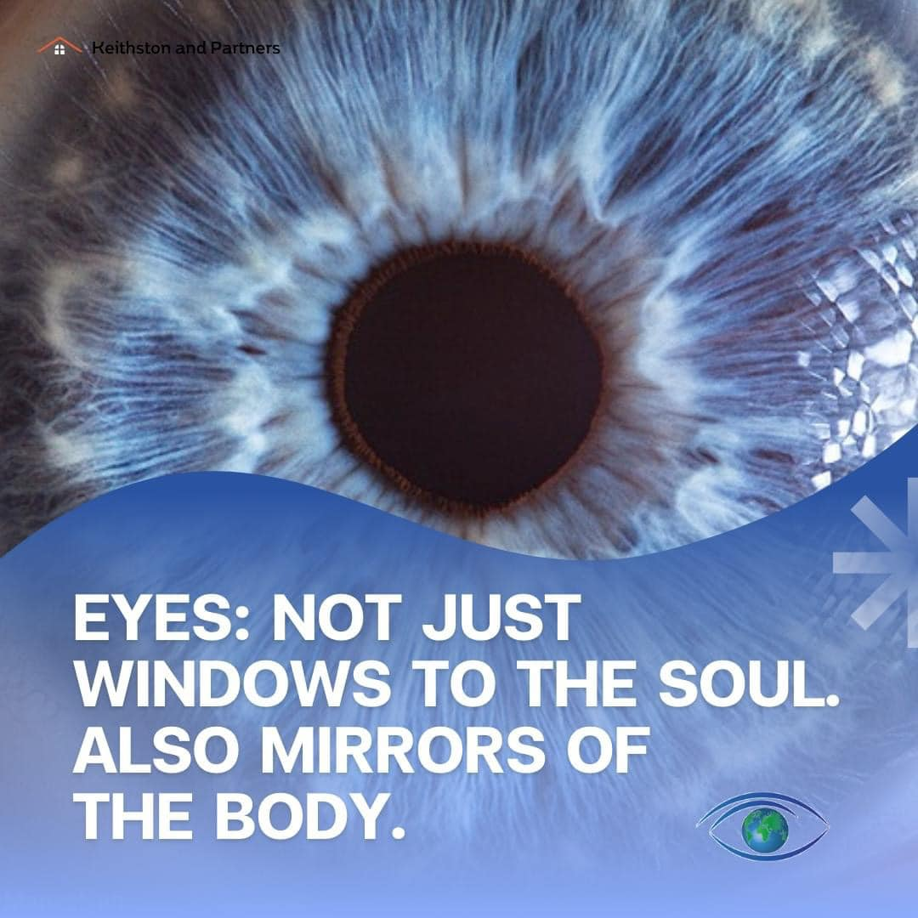
Yoga For Firefighters!
Did you all know that we have donation based yoga for firefighters on Monday nights at 6:30PM? Suzanne teaches these wonderful classes. If you are interested reach out to Suzanne at suzannefelli@yahoo.com
_______________________________________________________________________________________
Harvest Full Moon
Yoga Nidra Meditation

Please join me for a very special yoga meditation class called Yoga Nidra. This is not your typical mediation~ YN opens up doorways, releases blockages, it heals every organ, bone, muscle etc, it goes DEEP in to ALL levels of consciousness, releasing scars from traumas & abuses we have suffered from in this lifetime and more. Your YN takes you through the veils of life, afterlife, and previous lifetimes. We experience time travel, astro projection and it's also trippy! YN has an emphasis on health and healing where habitual thinking and thought patterns are reduced or eliminated. It also helps with insomnia and stress reduction and brings an incredible calmness, quietness, clarity and is one of the deepest of all meditations.
Yoga Nidra means Yogic Sleep and is a state of conscious Deep Sleep. In this Meditation, you remain in the Waking state of consciousness, and gently focus the mind, while allowing thought patterns, emotions, sensations, and images to arise and go on. However, in this meditation, you leave the Waking state, go past the Dreaming state, and go to Deep Sleep, yet remain awake. While Yoga Nidra is a state that is very relaxing, it is also used by Yogis to purify the Samskaras (negative energy & thought patterns). It’s also great for insomniacs and those who suffer with PTSD, as well as a powerful tool for manifesting. You will have the best sleep Monday night!!

The class is being held Monday, October 6th at 7:00 PM~ we hold our Yoga Nidra Meditation the first Monday of the month. The fee is $15, pre-registration is a must. To pre-pay & register safely http://www.bodyglyphix.com/upcomingclassesevents.html~ paying on line is $17 to cover our processing costs.
_______________________________________________________________________________________
Cannabis for Health & Wellness
Saturday November 1st at 2PM
Do you have questions about CBD products and cannabis in general?
Join us for an informative evening with Sean Kennedy, trusted cannabis advisor and holistic health enthusiast. There are 3 general categories of cannabis consumption: Adult-use, therapeutic, and medical. We will cover all 3 categories with an emphasis on therapeutic use and best practices for using cannabis to restore and maintain well-being. Due to chronic stress, illness/ injury, or traumatic events, the human endocannabinoid system becomes deficient in essential cofactors to regulate the nervous, immune and musculoskeletal systems. Proper supplementation with phytocannabinoids contained in the cannabis plant can restore homeostasis, relaxing the nervous system, boosting the immune system and improving function of the soft and connective tissue.
Sean will briefly share his personal experiences with cannabis over the last several decades and cover topics such as pain and anxiety relief, addiction recovery, methods of preparing and consuming cannabis, phytocannabinoids (THC vs CBD and terpenes), legacy vs legal market and cannabis breeding trends. There will be plenty of time for Q & A to ensure you leave feeling empowered on the topic of cannabis and your health.

Sample our Real NY CBD products!
Investment $15
*Limited seating*
you must RSVP 716-652-7805 or bodyglyp@msn.com
_______________________________________________________________________________________
FALL YOGA SCHEDULE
Times | Mon | Tue | Wed | Thu | Fri
9:30 am | Mystical  Vinyasa  Flow |  | Gentle  Healing  Yoga |  | Mystical Vinyasa  Flow
6:10 pm | Firefighter  Yoga | Mystical Vinyasa  Flow |  | Mystical  Vinyasa  Flow

Mystical Vinyasa Flow A nice blend of Hatha & Integrative Yoga, Pilates, Somatics, fused with Reiki, blended with the wisdom of the cosmos & mysticism of Gaia ~ geared to participants needs
Gentle Healing Yoga Gentle, healing Yoga- Yoga Therapy, Somatics and Energy Medicine Yoga fused with Reiki, blended with blended with the wisdom of the cosmos & mysticism of Gaia ~ geared to participants needs
Yoga Nidra The deepest- most healing meditation on the planet- the 1st Monday of the month at 7:00 PM
Life Goes Om Free Yoga Classes to anyone with Cancer or a life threatening disease
Class Prices $15 drop in fee or punch card fees- 8 classes $95 or 16 classes for $165
Yoga for Sports Yoga for Golfers, Runners or Snow- Sports $75 per hour
Yoga Therapy, Chakra Toning or Private Yoga by appointment $75 per hour
(click here for directions)
"Wishing you Heaven in your heart, starlight in your soul and miracles in your life in these changing times”
Your Suggestions and input are encouraged- as always!
When you support Rose's work on this planet you in-turn help support thousands of people worldwide to raise their consciousness and become empowered.
PROUDLY SERVING OUR COMMUNITY
we're here to provide exceptional service
In alignment with our values here at Bodhi Glyphix, we pride ourselves in offering an exceptional customer experience. Bodhi Glyphix was established in 1984 by Rose and to this day is a heart-based business run by a female spiritual entrepreneur.
The Bodhi Glyphix Studio/Rose Czyrny
12377 Big Tree Road, East Aurora, NY 14052
email: bodyglyp@msn.com
website: www.bodyglyphix.com
phone: 716.652.7805

