January 27, 2025 Issue 229The Iris The Bodhi Glyphix Studio

Greetings!
Thank you for allowing us into your world! Breathe deep- the crisp air, the quiet energies that flow through the planet and our bodies this time of year. Allow the energies of our planet to connect with our bodies. The earth sleeps in our part of the planet this time of year. So do our bodies, we find ourselves wanting to curl up with a good book or watch a good movie. Our bodies and the earth have much in common! We both have a heartbeat, magnetic poles, meridians/latitude/longitude lines and a pranic flow. We both have processes such as exfoliation, oxidation, and erosion. Think about processes of digestion and respiration as to plate tectonics, volcanism, and climate change. Earth has a respiratory system and humans have weather patterns and climate controls. Earth has a nervous system and humans have stress patterns and earthquakes. Earth has blood vessels, lungs, liver, and kidneys and humans have stream networks, neural networks, climates, and swamps. It is important for us to connect with Gaia, Mother Earth. Bundle up~ find time to get outdoors and take a walk. Getting grounded, absorbing the energy from our planet.
It’s also a good time to go within and reflect or to begin a meditation practice. Need help starting? Join us for a Yoga Class, or if you’re not comfortable joining a class, try a class on our yoga tube Channel in the comfort of your home. Here's the link, we ask a fee of $15 should you participate in a yoga video. If you have a punch card- you may just punch your card the next time you are in the studio. https://www.youtube.com/@roseczyrny
Should you no longer care to receive our info loaded newsletters, scroll down at the bottom is a place where you may unsubscribe. We are sorry to see you go.
______________________________________________________________________________________
Inclement Weather~ Studio Closings
As we head into winter, living in Western NY often brings weather with hazardous travel conditions. When the weather is inclement, and you are wondering if we are closed, if our internet/phone is up and running, you will receive an email. If we do not have a phone/internet connection, check channel 7 and 2 for closing status. Route 20A is kept clear, but look for our closing status, stay home and find the comfort in stillness, meditate or do some Yoga. Go to our You Tube Channel to take a yoga class in the comfort of your home. https://www.youtube.com/@roseczyrny
___________________________________________________________________________
Tips for Sinus Congestion
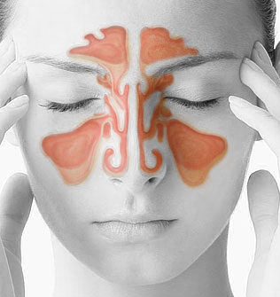
This time of year in WNY~ many find themselves ridden with sinus problems – pain, congestion, or worse, a sinus infection can quickly crop up and cause discomfort and misery is part of the itinerary. Here’s a very easy way to keep those sinus problems at bay with you breathing freely and clear during these times when viruses and bacterias are everywhere!! Then there's stress and bad eating from the holidays. Read on....
Prevent Sinus Problems with this Easy Tip
Most folks don’t realize that beneficial flora, also known as good bacteria, seek to dominate and protect every tissue of your body, not just your gut! There are plenty of beneficial bacteria in your mouth, throat, nasal passages and ears too.
When you get a sinus infection, the balance of good bacteria to bad (pathogenic) bacteria – including candida – becomes imbalanced with the baddies taking over with lots of mucus and possibly even an infection the result.
To prevent this from happening, after brushing/flossing your teeth at night before you go to bed, empty a probiotic !11 from NSP capsule into your mouth, swish it around in your mouth, and swallow. It is very important to not drink anything – even water – after you do this.
Enough probiotic residue will be left in your mouth after swallowing and these good little critters will migrate while you sleep all through your nasal passages, guarding the roost and helping to make sure no pathogens have an opportunity to take over and start plugging up the works. If you have dairy intolerance, most probiotic formulas are made from dairy. Search for a non-dairy, they are hard to find.
Already Have a Sinus Infection ? Use a ceramic neti pot and add to your filtered water (alternate these daily) 1/2 one Probiotic 11, 1/4 tsp celtic sea, 1/4 tsp of silver biotics your probiotic of choice to help clear up an existing sinus infection fast! With no antibiotics!Sniffing Silver Biotics into your nostrils is very effective. Take Silver Biotics orally and add for a tough infection- Olive Leaf or Myrr. We sell them at the Studio, they are always in stock. Also Probiotic 11 provides 11 species of live microorganisms that exert many beneficial health effects. Among other things, they support digestion, promote immunity and aid in the elimination of toxins. Can’t breathe, order or pick up at the studio Seasonal Allergy or Breath Activator.
⁎Don’t forget to eliminate dairy (it causes that mucous and weakens the immune!)
⁎Stop eating grains until you feel better!
⁎Try a 24 hour fast from foods (drink plenty of liquids, bone broth, Kombucha Tea, water)
⁎Do a colon & liver cleanse and/or a bone broth fast.
⁎Rest
⁎Acu-Yoga~ place your left fist into your right arm pit and hold for 30 seconds. Then place your right fist into your left TC pit and hold for 30 seconds. This opens up your sinuses quickly.
⁎Acu-Yoga~ Drilling Bamboo~ lying on your back, take your fingertips and press them into painful areas above your eye brows. Hold as long as you can tolerate. Try other points above your eye brows. This opens up your sinuses quickly.
⁎ Eat hot peppers, horseradish and radishes
⁎ Our Kali Rose has great safe herbals remedies that work! Message or call for helpers
_______________________________________________________________________________________

Let’s be Proactive this Year and be Healthy!

If you have not had Moxibustion (the alternative to the flu shot), you can still schedule an appointment with Rose. It takes less than 5 minutes. This can be done October through March. Moxibustion is a remedy which uses a Chinese homeopathic called Artemis Vulgaris which is used to warm the skin at the meridian associated with the immune. It wards off all influenzas by working the immune. Our statistics / effectiveness for the past 13 years, and is nearly 100%.
If you have been forced to have the influenza vaccination, we have herbal and homeopathic remedies here at the Studio for you to get the virus and toxins out of your body. The influenza vaccination can give you influenza and you can spread influenza to all you come in contact with (it’s called shedding) for 12 days. It’s important that you detox from t he vaccination. Call or email us for which detox is right for you. It’s best to be proactive if you have mandatory flu shots at your place of employment. We have plenty of Moxibustion supplies here at the Studio also. And will be “moxibusting” throughout March this year.

The Shingles and Pneumonia shot have the same risks as the influenza vaccination. Below lists the way to prevent:

1. Tap your thymus daily! (Center of Chest) 15 seconds (wakes up your immune)
2. Nature’s Sunshine D3 2 or 3 daily or Life Extension 5,000 or 7,000 IU’s daily
3. Nature’s Sunshine’s Probiotics 11 1 or 2 daily~ first thing in the morning on an empty stomach
To get Nature’s Sunshine products 30% off retail please call 1-800-223-8225 and mention acct# 9191 said to call.
4. Should you feel flu-like symptoms coming on- pick up patented (has a gov’t approved patent that this product can kill corona, MRSA, Anthrax and influenza viruses) Silver Biotics listed way below retail – $24- from our Studio or the Gel $24 (use it as a natural hand sanitizer)
5. Exercise/Yoga/Walking- key to staying healthy!
6. Get enough sleep 6-8 hours recommended for adults.
7. Wash your hands frequently!
8. Do not touch your face!
9. Lions Breath daily & when you have been around someone who’s sick.
10. Take a good Multi- Vitamin (Nature’s Sunshine Super Supplemental rocks)
11. Clean up your air & drink only filtered water.
12. Eat organic foods, avoid sugar, dairy & processed foods.
13. Use a Neti Pot daily.
14. Do a colon and liver cleanse regularly 2-4 times per month
15. Drink half your body weight in ounces of water daily and stay hydrated.
Most importantly!! See your local Holistic Practitioner (Rose Czyrny) regularly
___________________________________________________________________________photo heavy metals
Could Heavy Metals Be the Hidden Culprit Behind Your Health Issues?
Shocking News: 1 in 4 Americans may be suffering from heavy metal poisoning! Yes, you heard that right! Metals like mercury, lead, and arsenic might be silently altering your DNA and RNA, leading to devastating autoimmune diseases.
It's more than just feeling under the weather. These toxins are sneakily settling in organs like your thyroid, triggering diseases like Hashimoto's and Graves'. And guess what? The number of cases is skyrocketing due to increasing environmental toxins.
Science Speaks: Studies link mercury, cadmium, and lead to autoimmune nightmares like lupus, multiple sclerosis, and rheumatoid arthritis. It's just the tip of the iceberg.
But here's the scary part: mercury directly attacks our tissues, fooling our immune system into fighting our own bodies!
Ethical boundaries in research mean we can't test these effects directly on humans, but animal studies and overwhelming anecdotal evidence paint a clear picture of the havoc these metals wreak.
Good News: There's hope! Environmental physicians are finding that detoxing from these heavy metals can lead to significant, sometimes complete relief from symptoms.
Are you at risk? It's time to assess your exposure and take action to detox your body and environment. Your health might depend on it!
Are you ready to take control of your health? Message us and save $50 off the best detox recommended by the top Functional Doctors! Dr Tenpenny & Dr Carol Savage
_________________________________________________________________________
The Snow Walking (Snow Thermogenesis/Cryotherapy)
A little known means of improving your health
This healing modality can help you on soooo many levels! Have a bottle of warm water with you, a dry towel and shoes you may slip on when you have had enough. Here's some tips on walking in the snow:
So, how do I train for bare foot snow walking?
The most important thing to remember is that you are asking your body to adapt, so it will happen slowly and at your own body’s pace. Get your ego out of the picture, and decide to think of this as a long-term project.
The second thing to do is establish a regular outdoor cold walking schedule. For me, I take my dog out each morning and roll up my yoga pants and I do have a coat on. I attempt to stay out for about 2 to 10 minutes per session. If you are new, start with a minute or less. Breathe! Focus on your exhale. Allow yourself to feel the pain that comes with extremity training. When it hurts, go inside and warm your feet. You may use your hands or room-temperature water if you want. It’s not cheating.
Do this daily and try to focus on your feet when they get cold. Focus on the pain, and don’t ignore it. We are learning to listen to our body. If your feet go numb while doing this, you have waited too long to go inside. Go in quickly and heat your feet up.
You are training the blood vessels in your feet to open and close more effectively.
After you have noticed progress in your cold endurance, pick an object or a tree or a place that you can see in your neighborhood and make that your goal. Walk all the way to the goal and back. Gauge how easy or hard that was and adjust the goal for next time. It is okay to reduce the distance if it was too painful. Over time, as your feet become more adapted, choose targets that are further away.
Have a safety bag. Cold Therapy trainers insist that you should always carry a safety bag along when doing outdoor cold exposures. Remember that when you do a snow walk, every step that you take away from safety is a step that you will have to take again when you decide to return. Sometimes we misjudge how far we can actually go. Rather than lose a toe, bring a bag with a towel (to wipe off the snow and dry your feet), and some easy to slip into shoes. Socks are nice, but if you are really in dire need of footwear, they may be hard to manage. I usually have slip-on shoes in my bag.
Be patient with yourself. So, walk your own walk. You’ll get further on your own pace than if you tried to compete with someone else. In conclusion, I am all for pushing our perceived limits and overcoming fear. However, please remember that there is no shame in be safe about it. Cold training and Wim Hof Method are doorways to a longer and healthier life. It’s not magic. It’s mastery of our physiology and psychology. And mastery takes time, focus, and a lot of patience. You’ll get there my friend. We all will. One healthy step at a time.
Some Benefits of Cold Therapy & barefoot walking in the snow inc:
1. Heightened Exhilaration
2. An increased sense of well being
3.Increased Circulation (for all circ/vascular issues)
4. Reduced Inflammation
5. Increased Immunity
6. Grounding
7. Helps the body make it’s own endocannabinoids
8. Helps with anxiety, depression & bipolarity
9. Increased their metabolism and improved their blood sugar response.
10. Helps the body produce T Cells, cancer fighters.
11. Releases oxytocin, DMT, Norepinephrine and other feel-good hormones.
12. The cold water makes brown fat, a less dense fat in the body. It does not tolerate white fat, so it pretty much consumes it, hence we lose weight and fat.
__________________________________________________________________________
Do you do dry skin brushing? Why Not?
LADIES!
This is especially important to our breast health!
It's not just a beauty ritual, but a wellness game-changer for your lymphatic system! Here’s why you should consider it:
It helps detoxify your body
It can improve skin texture
It may boost circulation
It promotes lymph flow.
Just like I feed my passion for nutrition to help improve health, I'm here to educate on how little changes can make a big difference.
Make this a daily ritual  ps.... We only recommend a natural bristle brush. Make sure it’s a natural bristle brush, Lufas don’t do. You may find them in the candle dept at Vidlers. When in doubt….start at your extremities and brush towards your heart. I find brushing in circles arounds the breasts an excellent addition.

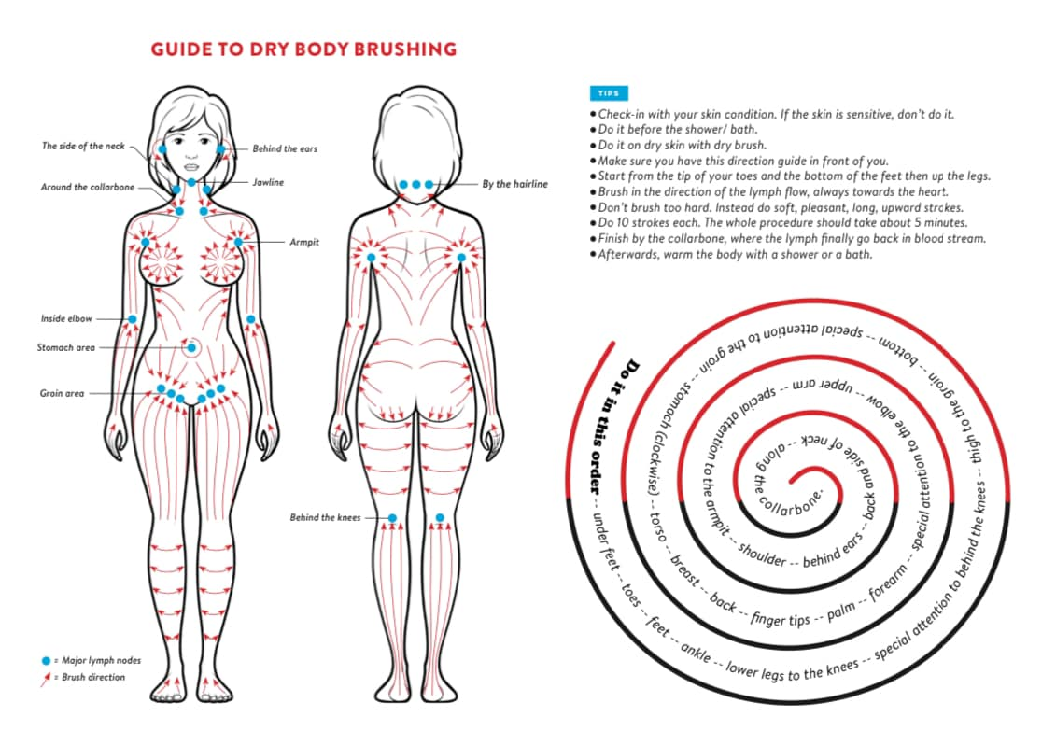

Jade Moon Milk
Jade Moon Milk - Named this because of its lovely color! Warm milk has long been the answer of mothers to soothe sleepless little ones. However, what happens when we become adults who experience sleeplessness? Warm milk in the form of “Moon Milk” along with the help of powerful herbs becomes the answer. Moon milk can be made with a wide array of milks, but today I am going to focus on oat milk. Oats are a wonderful source of tryptophan and magnesium, and even melatonin.
Butterfly pea flower (Natures Sunshine’s Love & Peas Protein Powder) is an excellent addition, too. It has been traditionally used in eastern medicine to promote relaxation in the evening. It also helps to create the soothing blue color. Chamomile, as many know, has long been used to promote relaxation.
Coupling all this with warming spices such as turmeric, ginger & cinnamon turns it into a “Golden Moon Milk”. These spices have a warming quality that aids in helping to relax the nervous system.
Ginger and turmeric are known as adaptogens. This means that they help the body adapt to stress.

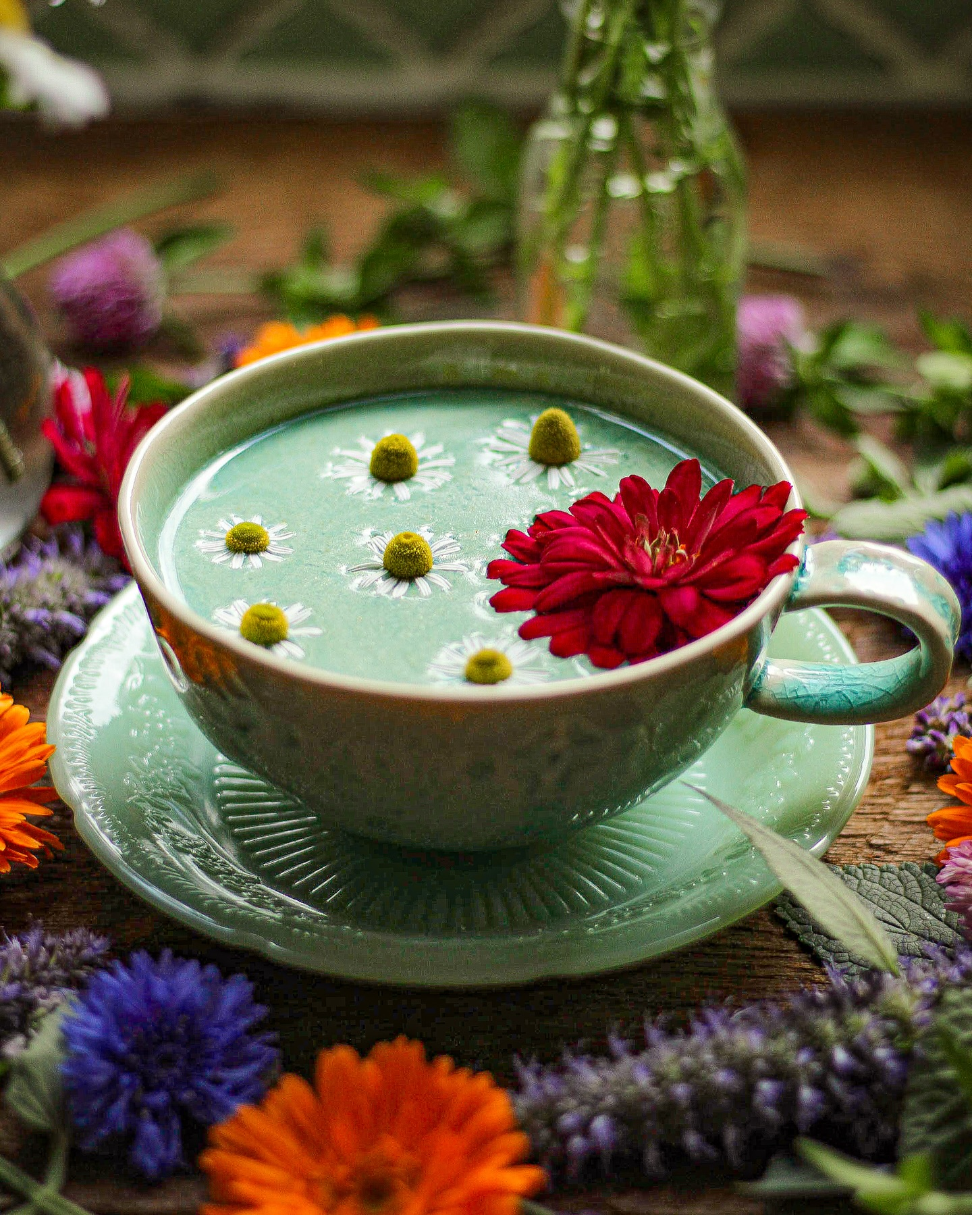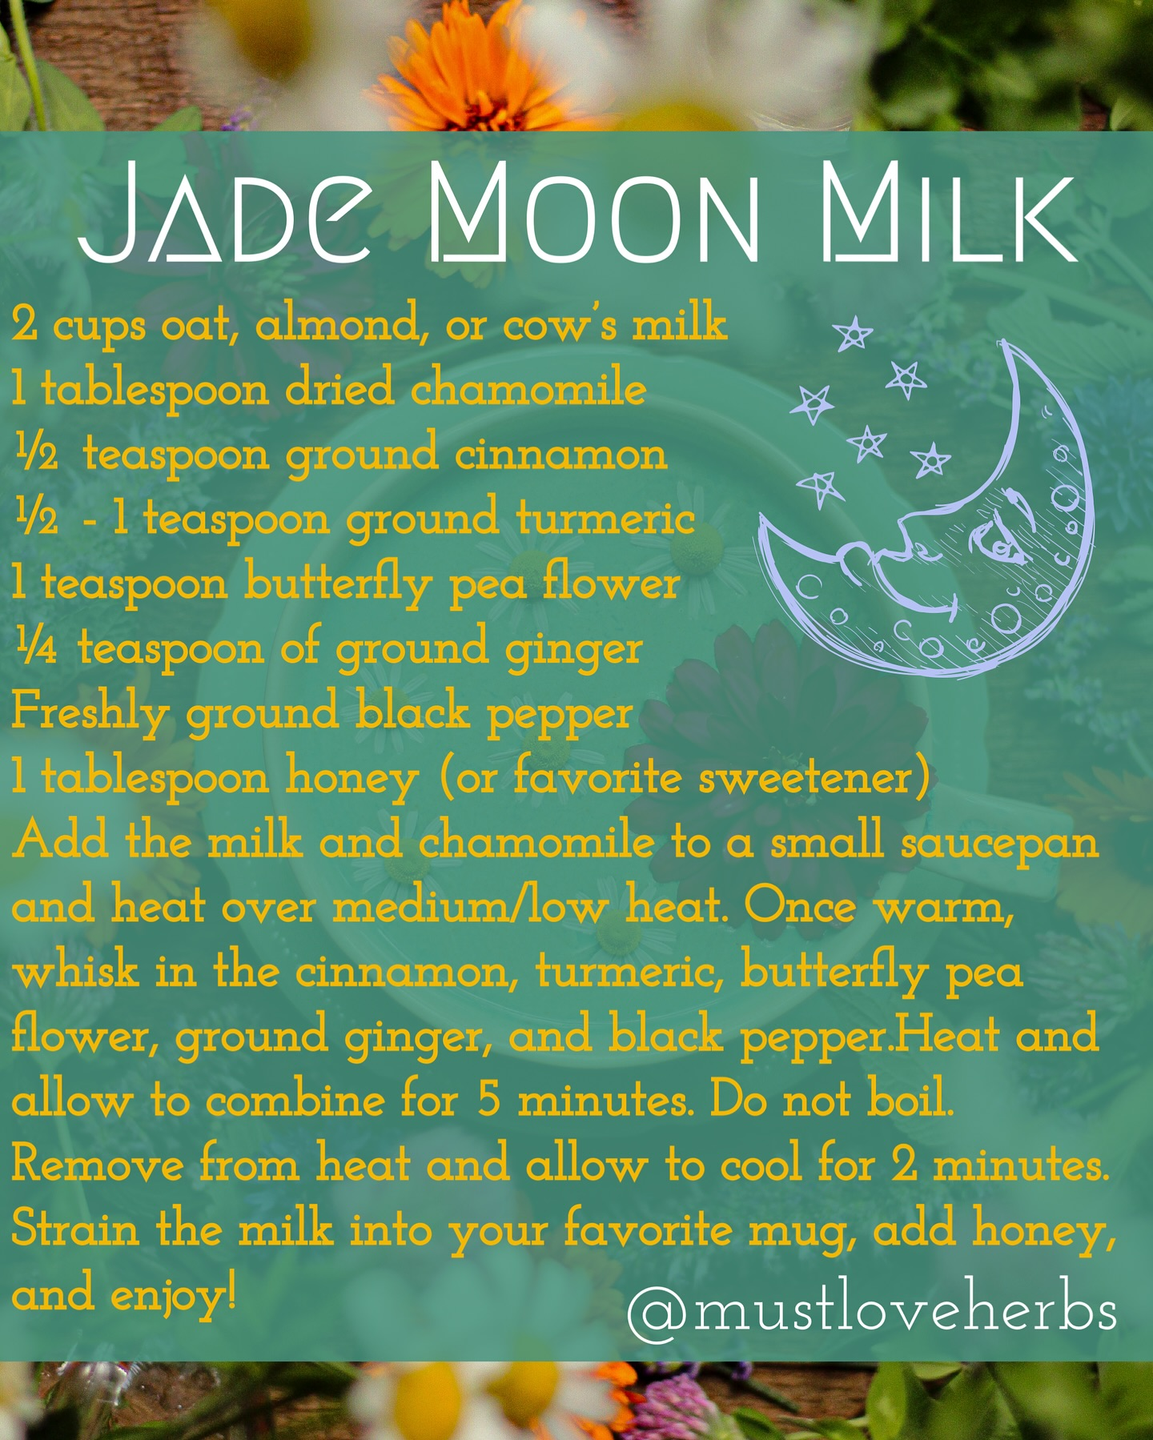
_______________________________________________________________________________________
WINTER YOGA SCHEDULE
Times | Mon | Tue | Wed | Thu | Fri
9:30 am | Mystical  Vinyasa  Flow |  | Gentle  Healing  Yoga |  | Mystical Vinyasa  Flow
6:10 pm |  | Mystical Vinyasa  Flow |  | Mystical  Vinyasa  Flow

Mystical Vinyasa Flow A nice blend of Hatha & Integrative Yoga, Pilates, Somatics, fused with Reiki, blended with the wisdom of the cosmos & mysticism of Gaia ~ geared to participants needs
Gentle Healing Yoga Gentle, healing Yoga- Yoga Therapy, Somatics and Energy Medicine Yoga fused with Reiki, blended with blended with the wisdom of the cosmos & mysticism of Gaia ~ geared to participants needs
Yoga Nidra The deepest- most healing meditation on the planet- the 1st Monday of the month at 7:00 PM
Life Goes Om Free Yoga Classes to anyone with Cancer or a life threatening disease
Class Prices $15 drop in fee or punch card fees- 8 classes $95 or 16 classes for $165
Yoga for Sports Yoga for Golfers, Runners or Snow- Sports $95 per hour
Yoga Therapy, Chakra Toning or Private Yoga by appointment $95 per hour

"Wishing you Heaven in your heart, starlight in your soul and miracles in your life
in these changing times."

The Bodhi Glyphix Studio
Rose Czyrny
12377 Big Tree Road, East Aurora, NY 14052
email: bodyglyp@msn.com
website: www.bodyglyphix.com
phone: 716.652.7805

