April 27th, 2023 Issue #209 The Iris The Bodhi Glyphix Studio

Greetings!

Thank You for allowing us into your world! Welcome to our monthly newsletter! Please feel free to share this via email or social media. If you no longer wish to receive to receive our newsletters, plz scroll down to the bottom and unsubscribe.
May is the time to clean our Blood & Skin~ May I suggest some products which I have the best results with my clients??? Any skin issue responds well to Nature’s Sunshine’s Oregon Grape or BP-X Formula. May I also suggest Nature’s Sunshine Liquid Chlorophyll ES (it’s the only one on the market that’s paraben free) and Red Clover are great also! What one works best for you? This can be determined with Energy Work during a Body, Mind & Soul Consultation. Maybe you are due for a follow up…. Or perhaps you are interested in unlocking the mystery of your issues. Rose goes to the root of the problem, rather than treating the symptoms. To learn more about what it is about go to http://www.bodyglyphix.com/services.html
_______________________________________________________________________________________
Do you have Leaky Gut?
Inside our bellies, we have an extensive intestinal lining covering more than 4,000 square feet of surface area. When working properly, it forms a tight barrier that controls what gets absorbed into the bloodstream. An unhealthy gut lining may have large cracks or holes, allowing partially digested food, toxins, and bugs to penetrate the tissues beneath it. This may trigger inflammation and changes in the gut flora (normal bacteria) that could lead to problems within the digestive tract and beyond. The research world is booming today with studies showing that modifications in the intestinal bacteria and inflammation may play a role in the development of several common chronic diseases.
Who gets a leaky gut (and why)?
We all have some degree of leaky gut, as this barrier is not completely impenetrable (and isn’t supposed to be!). Some of us may have a genetic predisposition and may be more sensitive to changes in the digestive system, but our DNA is not the only one to blame. Modern life may actually be the main driver of gut inflammation. There is emerging evidence that the standard American diet, which is low in fiber and high in sugar and saturated fats, may initiate this process. Heavy alcohol use and stress also seem to disrupt this balance. Dairy, genetically modified wheat, corn and soy also damage the intestinal lining and flora.
“Symptoms of Leaky Gut”, it said in big bold letters at the top. And then a laundry list of symptoms:
Excessive bloating, gas, painful cramps
Food sensitivities and nausea after meals
Chronic fatigue, brain fog, and headaches
Achy joints and muscles, limited mobility
Unusual hair thinning, hair loss and brittle nails
Dull skin prone to rashes and wrinkles
Trouble falling asleep or staying asleep
Mood swings, irritability and anxiety
Autoimmune disorders or poor immune system
Hashimotos and other Thyroid diseases
Irritable Bowel, Colitis and Crohns disease
Some studies have shown it may contribute to (lupus, type 1 diabetes, multiple sclerosis), chronic fatigue syndrome, fibromyalgia, arthritis, allergies, asthma, acne, obesity, and even mental illness.

Repairing the intestinal lining requires cleaning up the diet, the right probiotic, herbs and minerals that can repair the gut once you have cleaned up your diet. Everyone resonates with different products; our Rose has been helping people with their health for over 40 years. Think you might have leaky gut? Reach out to Rose for a Body, Mind & Soul consultation. A bone broth fast is a good start along with changing your diet.
___________________________________________________________________________
So Many of you are asking me how to….
Bone Broth for Healing
Leaky Gut, IBS, Weight Loss and Intestinal Issues

Reset/Reboot your system! Do a bone broth fast for 3 days up to 7 days.
Ingredients
2 lbs beef , venison, fish or chicken bones (organic grass fed are best, but chicken necks or oxtails can be used also) 2-3 gal. Cold filtered water
1/2 cup Braggs Apple Cider Vinegar
1 tablespoon of celtic or himalayan sea salt
3 onions, coarsely chopped (optional) 3 carrots coarsely chopped (optional) 3 celery sticks coarsely chopped (optional) Several sprigs of fresh thyme, tied together. (optional) 1 tsp. dried green peppercorns, crushed (optional) 1 bunch parsley (optional) or any herbs, spices of your choice.

Instructions
Place the bones in a very large stockpot with vinegar and cover with water. Let stand for one hour. Add to the stock pot the vegetables. A large amount of scum (looks like bubbles/oil slick) will come to the top and this needs to be skimmed off with a spoon & discarded. After you have skimmed, reduce heat and add the thyme and peppercorns. Simmer for at least 12 hours and up to 72 hours (about 24 works well for me). The longer you cook it~ the more collagen & nutrients are released from the bones. For the last 10 minutes, add the parsley. A crockpot can also be used to simmer the stock if you are leaving the house for extended periods of time. Remove bones with tongs and discard. Strain the rest of the stock into a large bowl. Let cool in the refrigerator and remove the congealed fat that rises to the top, stock may turn to gelatin when cooled (if knuckles are used), this is normal. Put the vegetables back into the stock. I make mine in a crock post, it is much easier.

I recommend this as a fast or in addition to your diet. This is VERY complimentary to the GAPS diet- always according to your blood type. The GAPS, Paleo, Blood Type or AIP diet, the most healing diets today. Just google them~ I enjoyed the Paleo & Blood Type diet for over a year and still follow it pretty regularly (should you need some coaching~ message or call me for an appointment). I have introduced many foods back into my diet and found the ones that I am sensitive to and have completely eliminated them, feeling the best that I have ever felt in my life. Being in control of your health is the greatest wealth on the planet.

The AIP diet is great for auto-immune issues. Always refer to your blood type for the best results.
Bone broth fasting repairs, reboots and restores the gut
is also great for weight loss, thyroid and/or adrenal issues, and so much more. Please refer to your blood type diet for the best results. The bones used should be organic, I have found a nice selection at Thorpes here in Wales. After making your bone broth, try 1-3 days of the broth (without the vegetables) instead of meals. Drink plenty of filtered water, herbal teas. Limit caffeine to one serving per day. Take your supplements, medications as usual.

When you feel you need to add vegetables (that you made the bone broth with) to your bone broth meals, you may. This fast can be done for a week for the best results. One day of the fast will help a little, but try to make it at least 3 days. You will feel amazing after the first day and the more you partake in periodic fasting. You may also do just one day! Or micro-fasting, skip a meal daily for 2-3 weeks and gain some benefits. So many people agree how great they feel. Pain and inflammation disappear like magic!!!
Or reach out to me~ there are cleanses that I recommend for those who would rather do a full body cleanse, liver detox, chelation that Natures Sunshine has the right cleanses that are also great!!!
______________________________________________________________________________________

PETS & TOXINS
Did you know pets are 7x more polluted than we are? They are curious creatures and are close to the ground.
There are many ways our pets are exposed to toxins:
Dog Foods
Dog treats
Dog toys
Salts
Molds
Supplements
Lawn
Insecticides
Pesticides
Pavements
Indoor Floors
The list goes on…
The following studies show results of how Clinoptilolite (zeolite) has been used safely and effectively on pets for years.
Anti tumor in canine The properties tested n this article are anticancer and antioxidant.:
https://pubmed.ncbi.nlm.nih.gov/11434724/
Digestive health/microbiome:
https://pubmed.ncbi.nlm.nih.gov/27713735/
Some ways you can use Zeolite for pets:
Spray in the morning in the afternoon or add to their food or use topically if they have any hot spots of skin irritations.
Should you like to try PBX Zeolite, a $50 discount code is available for first time user. Send me a direct message for the code with your email address. I will send you two emails, one with the link and the discount and another email with directions.
ps…..
The above photo is a picture of my 13 year old Jasper, he is in excellent shape for his age. I do use the detox spray on him3 times a year. Spring and Fall are good times for parasites (line it up with the full moon when parasites are most active) for 2 months and another time or two and just for a few weeks.
_________________________________________________________________________

Detox Bath
I absolutely LOVE detox baths and swear by them. They help myself, clients, friends & family feel better, and help maintain a good amount of magnesium in their bodies. Magnesium is a wonderful mineral that is essential in our overall health. But most of us are deficient in this important nutrient. Magnesium Flakes or
Epsom Salt helps maintain a good level of magnesium, and can help with your overall health.
Detox Baths have amazing benefits including:
•Fight Colds Fast
•Promote Better Sleep
•Help Eliminate Toxins
•Relieve Irritability and Stress
•Improve Focus And Brain Activity
•Alleviates Muscle Pain
•Helps Blood Glucose Control
•Improves Drainage Pathways
•Reduce Oxidative Stress
You can customize your baths! These are some of my favorite things to add. Epsom Salts~ Love Dr Bronners! I use cheap Apple cider vinegar, it works better at pulling toxins out, Celtic Sea Salt, Bob Red Mill Baking Soda and lalalalove adding a drop or two of Rose Oil.
What are your favorite things to add?
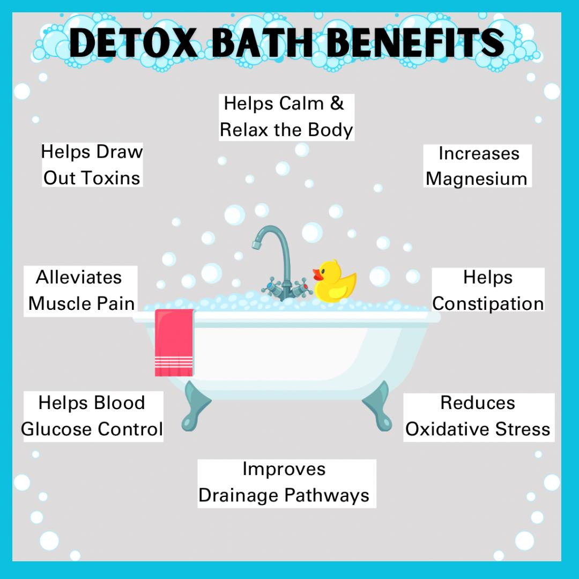
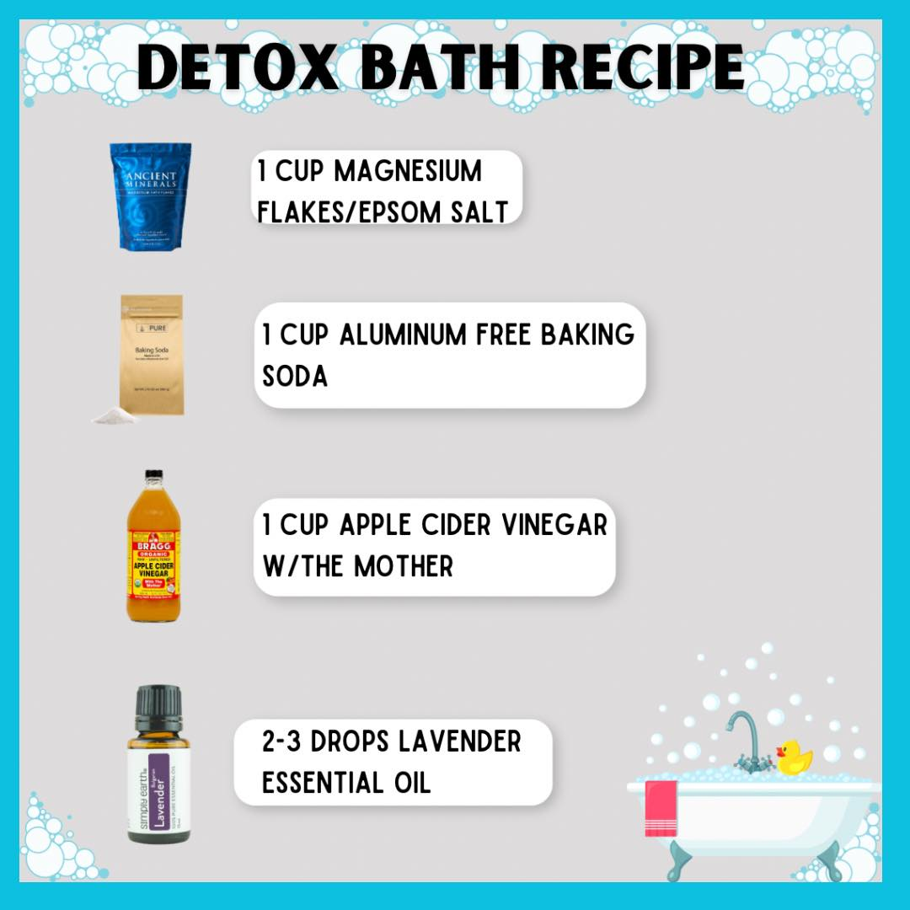
_____________________________________________________________________
Yoga Nidra Meditation
SOLD OUT!!!

Please join Rose for a very special yoga meditation class called Yoga Nidra. This is not your typical mediation~ YN opens up doorways, releases blockages, it heals every organ, bone, muscle etc, it goes DEEP in to ALL levels of consciousness, releasing scars from traumas & abuses we have suffered from in this lifetime and more. Your YN takes you through the veils of life, afterlife, and previous lifetimes. We experience time travel, astro projection and it's also trippy! YN has an emphasis on health and healing where habitual thinking and thought patterns are reduced or eliminated. It also helps with insomnia and stress reduction and brings an incredible calmness, quietness, clarity and is one of the deepest of all meditations.
Yoga Nidra means Yogic Sleep and is a state of conscious Deep Sleep. In this Meditation, you remain in the Waking state of consciousness, and gently focus the mind, while allowing thought patterns, emotions, sensations, and images to arise and go on. However, in this meditation, you leave the Waking state, go past the Dreaming state, and go to Deep Sleep, yet remain awake. While Yoga Nidra is a state that is very relaxing, it is also used by Yogis to purify the Samskaras (negative energy & thought patterns). It’s also great for insomniacs and those who suffer with PTSD, as well as a powerful tool for manifesting. You will have the best sleep Monday night!!

The class is being held Monday, May 1st at 7:00 PM~ we hold our Yoga Nidra Meditation the first Monday of the month. The fee is $13, pre-registration is a must. To pre-pay & register safely http://www.bodyglyphix.com/upcomingclassesevents.html~ paying on line is $15 to cover our processing costs.
_______________________________________
SPRING YOGA SCHEDULE

Times | Mon | Tue | Wed | Thu | Fri
9:30 am | Mystical  Vinyasa  Flow |  | Gentle  Healing  Yoga |  | Mystical Vinyasa  Flow
6:10 pm |  | Mystical  Vinyasa  Flow |  | Mystical  Vinyasa  Flow

Mystical Vinyasa Flow A nice blend of Hatha & Integrative Yoga, Pilates, Somatics, fused with Reiki, blended with the wisdom of the cosmos & mysticism of Gaia ~ geared to participants needs
Gentle Healing Yoga Gentle, healing Yoga- Yoga Therapy, Somatics and Energy Medicine Yoga fused with Reiki, blended with blended with the wisdom of the cosmos & mysticism of Gaia ~ geared to participants needs
Yoga Nidra The deepest- most healing meditation on the planet- the 1st Monday of the month at 7:00 PM
Life Goes Om Free Yoga Classes to anyone with Cancer or a life threatening disease
Class Prices $13 drop in fee or punch card fees- 8 classes $88 or 16 classes for $155
Yoga for Sports Yoga for Golfers, Runners or Snow- Sports $85 per hour
Yoga Therapy, Chakra Toning or Private Yoga by appointment $85 per hour (click here for directions)
______________________________________________________________________________________

"Wishing you Heaven in your heart,
starlight in your soul and miracles in your life in these changing times”
The vibrational rate of our planet is quickening
Our bodies must make the vibrational change with the planet
Find down time, practice Yoga & Meditation

The Bodhi Glyphix Studio
Rose Czyrny
12377 Big Tree Road
East Aurora, NY 14052
email: bodyglyp@msn.com
website: www.bodyglyphix.com
716.652.7805

