March 27th, 2023 Issue #208 The Iris The Bodhi Glyphix Studio

Greetings!
Are you feeling a bit heavy~ Body, Mind & Soul? The long hard winter and lack of sunshine can cause lethargy and depression. Our Root Chakra misses being connected to the earth~ as for most of us have been house bound. Or perhaps you are a bit anxious from the past mercury retrograde and the energy of the spring equinox. With the transition of Spring and reconnecting to the revitalization of our energy through the flow of Shatki (from the composting of winter in the new cycle), that dormant energy that sits at the base of our spines rises. Practicing Yoga awakens this sleepiness in our body, mind & souls. Our Yoga Class schedule is at the bottom of the newsletter. Check it out and please ty a class, or two or three.
Would you like to try our yoga classes before coming to an actual class?

Many folks do not realize we have a You Tube Channel. Yes! Welcome to our Yoga Classes in the comfort of your home. Our Kali Rose Czyrny is a certified Yoga Therapist and instructor with 45 years’ experience. Weaving info of the cosmos, earth, our body, mind & soul in a soft or invigorating but always healing practice. As always, do what you can and leave the rest. Our focus is on healing the body, mind & the soul. Rose likes to focus on the lower back and pelvic floor liberation, the diaphragms that effect our structural systems, body functions and organs. Our videos are available for $13 per viewing. Should you have a punch card, you may use your punch card that is in the Studio. Let us know and we can punch your card. Here’s our You Tube Channel….
https://www.youtube.com/channel/UCN_mttLrqw1KBNC6TdQl50Q

We hope you enjoy our newsletters! Should you wish not to receive these electronic newsletters- you always have an opt out option by clicking the link at the bottom of this newsletter…
______________________________________________________________________________________
The Studio is Closed April 9th through the 16th
Our humble studio needs a rest and deep cleaning! Please let your friends that may not receive these emails, greatly appreciate you sharing. If you need supplements, to make an appointment, please do so before. Hoping you can embrace the week to reflect and roll out your yoga mat, take a walk/hike or just to be still.
_______________________________________________________________________________________
Spiritual Baths
recipes & more
https://www.qhhtofficial.com/healing/spiritual-bath/?fbclid=IwAR1T6jWdHvzqI_26uwYO2uCx-G1Y4YesjGNqJw854223JVNJf7UqCQ6kvqM
_______________________________________________________________________________________
We Carry a Top Line of CBD Oil & Products
Stressing about our social separation and the effects forth coming from many not being able to work or too much on your plate? After many years of researching and spending over thousands of dollars trying and testing different brands, Bodhi Glyphix carries a line of superb CBD Oils and products at our Studio. CBD derived from the whole hemp plant. It is but one ingredient, no fillers, non-gmo, USA Hemp Authority Stamp of Authenticity and it comes with a 60 day empty bottle guarantee satisfaction or your money back.
I was diagnosed with Lyme Disease and Epstein Barr on top of having the parasite, bringing lots of pain and inflammation. In just 2 weeks, all of my inflammation was gone, the neuropathy (from my parasite in 2008) in my feet is gone, anxiety is gone and I am sleeping better! I didn’t realize I had inflammation or sleep issues, until I began Hempworx CBD Oil. I have been dealing with stress, for a VERY long time, but I honestly say I feel at peace with it all. Something I could never say before. Many people are saying how it helps with stress management, high blood pressure, fibromyalgia, menopausal issues, auto immune regulation, arthritis, colitis, irritable bowels disease, acid reflux, tinnitus, skin issues and I could go on and on. Interested in taking a peek at these great products? Go to hempbodhi.com You may also purchase there as well, just go to shop.

Might I suggest that many people are attracted to the peppermint and cinnamon flavored CBD Oils, but honestly, start out with the natural, the flavors are all organically derived but can be too fiery on the stomach. I would suggest most people have better results with the 750 mg also or 1500 MG. You may always message us for instructions when using them. Their CBD Bath Bombs are the BOMB!! You may use one bathbomb 3 times, just take it out of the water when it’s one third dissolved. I also like their “Relief” pain crème. I do use there restoring & healing night time moisturizer “Revive.”
_______________________________________________________________________________________
Do you Satapavali?
After eating a meal the worse thing you can do is sit down and watch TV allowing the food to sit causing huge amounts of circulatory stress. Satapavali is an Ayurvedic term that refers to the age-long Indian custom of taking a stroll after a meal. Studies show that taking 100 steps after you eat all meals it lowers blood sugar levels. After walking after a meal the blood sugar gets right into the muscles without the needed insulin and lowers blood sugars. If you walk after a meal, the food leaves the stomach more quickly preventing acid reflux, GERD or heart burn. A study showed that walking after a fatty meal, it significantly lowers triglycerides.
Please, move after every meal.
_______________________________________________________________________________________


EMOTIONAL PSOAS
“One thing you can’t hide – is when you’re crippled inside.” ~ John Lennon
Pelvis is shaped like a bowl and the spine just like a straw that is dipped in the bowl connecting the brain to the entire network in the body. A complex unit of muscles, bones, tendons, fascia fibers and ligaments, pelvis houses integral muscles connecting the upper and lower extremities. Our mind often tucks away emotions, stress, pain in the confines of the hip bowl. That is why our hips are referred as the junk drawer or the storage room for dodged emotions.
Hips acquire a central role in our lives. The main muscle groups of the hip flexors, iliopsoas muscles, sartorius and Rectus Femoris, are responsible for the flight, fight and freeze response in the body.
“Our ancient (reptilian) brain recognizes danger by smell, look, feel and sound.” Since childhood, our sympathetic nervous system prepares your body for any form of dangerous, stressful situation or sudden shock by contracting the hip flexors and the muscles in the middle body.
Parasympathetic nervous system, responsible for ‘rest and digest’ or ‘feed and breed’ syndrome neutralizes the impact of the sympathetic nervous system and creates a sense of harmony in the body.
But due to highly strenuous atmosphere and surroundings, our body resets the benchmark of usual state of being, when it comes to stress and shock. Simply put, the body is chronically stressed and the hip flexors are on alert throughout.
But by now, the body recognizes tightness of hip flexors and suppressed emotions, to be a natural state of being. This leads to hampering the functions of the autonomic nervous system.
Psoas Muscle – Trauma to Recovery
A significant part of instinctual reflexes, psoas is the only flexor muscle connecting the spine to the legs and fasciae connecting to the diaphragmatic breathing system. Tight psoas muscle therefore, leads to shortness of breath or chest breathing, adding on to stress further. The cyclical motion of stress, which indirectly affects psoas and tight psoas attributing to stress levels cannot be broken until an external stimulus is injected.
The fear of falling, getting into a dangerous situation is yet another instinctual reflex. As the body recognizes such a situation, it slips into a safety zone. “ the psoas pulls the extremities together into a fetal pose, creating an enclosure, a sense of safety and protection for the soft, vulnerable parts of the body: Genitals, belly organs, lungs, heart and face. Curled, the spine gives the necessary resilience and strength against the imminent blow.”
The emotional traumas imbalance the deep core along with the psoas and creates restrictions in the root and sacral chakra.
After a trauma, it is the ardent need of the body to come back in safety restoration mode. But just by telling someone that they are safe, the restoration does not fall back. The body has its own system to break free from the setback.
Sometimes this breakthrough comes through re-enactment of an incident in the mind and a feeling of overcoming it. We release the deeper levels of emotions gradually, as the feeling of safety starts to set in. But the frozen residual traumatic energy is still left in the psoas and hip area, as some of the strongest muscles are situated in this region.
So, what should one do to release the psoas muscles? Just by massaging the psoas muscles or activating them, we might trigger the memories of the past.
A conscious awareness, resolved psoas (of the facilitator like the chiropractor or yoga teacher) and supportive positioning can lead to a gradual recovery.
Our Yogini Rose weaves Pelvic Floor exercises/asanas into her Yoga Classes. She has done extensive training for over 2 years now. If you have had a hysterectomy (partial or full), any surgery in your abdomen, any kind of incontinence, rectoceles, irritable bowel, Crohn’s disease, colitis, prostate issues, urinary track issues ans do much more. Pelvic floor work is for you!
___________________________________________________________________________________________________________________________
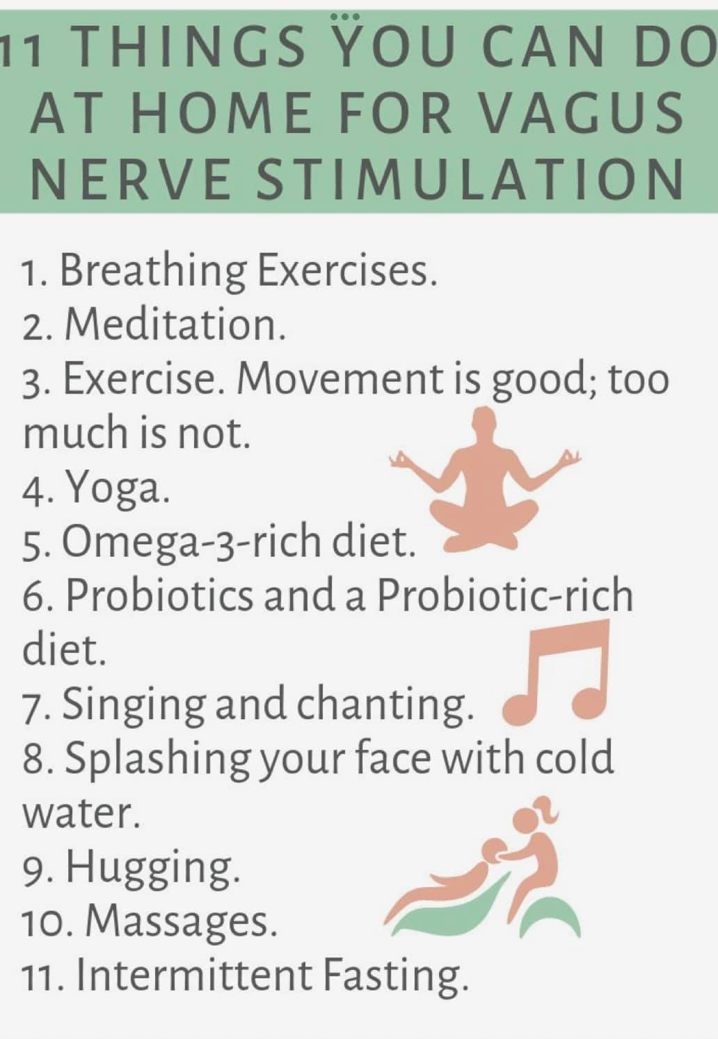
The Role Of The Vagus Nerve In Regulating Inflammation And Immune Response
Did you know that the vagus nerve plays a critical role in regulating inflammation and immune response in the body? The vagus nerve is the longest nerve in the body and runs from the brainstem all the way down to the abdomen, connecting many of the body's organs.
Studies have shown that the vagus nerve can activate an anti-inflammatory response in the body that can help reduce inflammation and improve the body's immune response. When the vagus nerve is stimulated, it releases a neurotransmitter called acetylcholine that reduces inflammation and boosts the immune system.

Research has also found that people with disorders such as rheumatoid arthritis, inflammatory bowel disease, neck injuries, concussions and psoriasis have reduced vagal activity, leading to higher levels of inflammation and a weakened immune response. It helps with stress and inflammation. As I continue to study this amazing nerve bundle,it has also been shown to help autistic children and adults and epilepsy. It regulates insulin levels and blood pressure. Has helped many with concussions and neck injuries.

So how can you stimulate the vagus nerve? Deep breathing, yoga, meditation, and even laughter have all been shown to activate the vagus nerve and reduce inflammation in the body. Incorporating these activities into your daily routine can have a significant impact on your overall health. Or you can spend a little or a lot of money by purchasing an ultrasound device. I can give you a link if interested. If you are on social media Facebook, Sterling Cooley is a brilliant coach for Vagus Nerve support. Heres his page https://www.facebook.com/groups/thevagusnerve

It's essential to remember that a healthy immune response is critical for fighting off infections and diseases. By understanding the role of the vagus nerve in regulating inflammation and immune response, we can take proactive steps toward improving our health and wellbeing.
Our Rose Czyrny teaches Vagus Nerve exercises in all yoga classes and to clients who may need help during a consultation. If you are a client and you are reading this, next time you have an appointment ask Rose for a simple technique for your Vagus Nerve. Yoginis know we always work the Vagus Nerve in all classes. Never been to a Yoga Class? Scroll down and come and join us for some self healing techniques.

_____________________________________________________________________
Yoga Nidra Meditation

Please join me for a very special yoga meditation class called Yoga Nidra. This is not your typical mediation~ YN opens up doorways, releases blockages, it heals every organ, bone, muscle etc, it goes DEEP in to ALL levels of consciousness, releasing scars from traumas & abuses we have suffered from in this lifetime and more. Your YN takes you through the veils of life, afterlife, and previous lifetimes. We experience time travel, astro projection and it's also trippy! YN has an emphasis on health and healing where habitual thinking and thought patterns are reduced or eliminated. It also helps with insomnia and stress reduction and brings an incredible calmness, quietness, clarity and is one of the deepest of all meditations.
Yoga Nidra means Yogic Sleep and is a state of conscious Deep Sleep. In this Meditation, you remain in the Waking state of consciousness, and gently focus the mind, while allowing thought patterns, emotions, sensations, and images to arise and go on. However, in this meditation, you leave the Waking state, go past the Dreaming state, and go to Deep Sleep, yet remain awake. While Yoga Nidra is a state that is very relaxing, it is also used by Yogis to purify the Samskaras (negative energy & thought patterns). It’s also great for insomniacs and those who suffer with PTSD, as well as a powerful tool for manifesting. You will have the best sleep Wednesday night!!

The class is being held Monday, April 3rd at 7:00 PM~ we hold our Yoga Nidra Meditation the first Monday of the month. The fee is $13, pre-registration is a must. To pre-pay & register safely http://www.bodyglyphix.com/upcomingclassesevents.html~ paying on line is $15 to cover our processing costs.
_______________________________________________________________________________________
Protecting Yourself Against 5G
https://www.drnorthrup.com/7-habits-to-boost-your-emf.../
________________________________________________________
SPRING YOGA SCHEDULE

Times | Mon | Tue | Wed | Thu | Fri | Sat
9:30 am | Mystical  Vinyasa  Flow |  | Gentle  Healing  Yoga |  | Mystical Vinyasa  Flow
6:10 pm |  | Mystical  Vinyasa  Flow |  | Mystical  Vinyasa  Flow

Mystical Vinyasa Flow A nice blend of Hatha & Integrative Yoga, Pilates, Somatics, fused with Reiki, blended with the wisdom of the cosmos & mysticism of Gaia ~ geared to participants needs
Gentle Healing Yoga Gentle, healing Yoga- Yoga Therapy, Somatics and Energy Medicine Yoga fused with Reiki, blended with blended with the wisdom of the cosmos & mysticism of Gaia ~ geared to participants needs
Yoga Nidra The deepest- most healing meditation on the planet- the 1st Monday of the month at 7:30 PM
Life Goes Om Free Yoga Classes to anyone with Cancer or a life threatening disease
Class Prices $13 drop in fee or punch card fees- 8 classes $88 or 16 classes for $155
Yoga for Sports Yoga for Golfers, Runners or Snow- Sports $85 per hour
Yoga Therapy, Chakra Toning or Private Yoga by appointment $85 per hour (click here for directions)

"Wishing you Heaven in your heart, starlight in your soul and miracles in your life in these changing times" The vibrational rate of our planet is quickening- the vibrations have a dominant masculine force.
Yoga and meditation are very helpful with this transition….
The Bodhi Glyphix Studio
Rose Czyrny
12377 Big Tree Road, East Aurora, NY 14052
email: bodyglyp@msn.com
website: www.bodyglyphix.com
phone: 716.652.7805

