August 27th, 2022 Issue #203The Iris The Bodhi Glyphix Studio

Greetings!
Labor Day is on our heels. The summer is fading gracefully into the ethers as we pirouette with our Earth Mother in a rhythmic dance, ebbing and flowing with the new cycles of life as Fall moves in. In this recent turning of the tide, we find that our changing rhythm follows a slower breath, a softer stride. Learn more through our Yoga Classes and Body, Mind & Soul Consultations….. see our Yoga schedule below.
_______________________________________________
If you “grew up” in the 60s, 70s, 80s, or early 90s, a lot of the processed food you ate back then is NOT the same food you are consuming today
Often I hear people say... What’s the big deal? I ate Frosted Flakes all the time as a kid, and I’m just fine.
Here’s the real answer. If you are older than 30, the Frosted Flakes ingredients you ate are not the Frosted Flakes ingredients today in that Tony the Tiger box.
1983- aspartame was allowed in carbonated drinks
1988- FDA approved ace-k
1993- FDA approved rBST and rBGH growth hormones for cows
1994- FDA began approving GMOs in food supply
1996- Roundup Ready soy approved for US food supply
1998- Roundup Ready corn approved for US food supply
1998- GMO canola approved
2000- organic labeling implemented
2007- GMO sugar beets approved
Should I keep going? author unknown

_______________________________________________r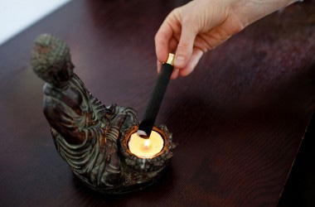
MOXIBUSTION~ The Alternative to the Flu Shot
Exclusively at our Studio
Starting September 7th through the Spring
This is the 16th year our humble Studio has offered this little known modality. I believe we are the only Studio in all of upstate NY to offer this technique. Moxibustion is a homeopathic remedy using Artemis Vulgaris which is used as a warming agent of the meridian associated with the immune, effective against ALL strains of influenza (except- the stomach flu which is not a true flu). It may even help with the Ebola Virus. The effectiveness against all influenza is around 99%. It is a 2 minute procedure. It has been documented that this year’s medicinal Flu Vaccine is what’s left over from last year, the drift collaborated from last year’s influenza. Educated people know that the strains that affect us morph/change every 10 days. You cannot use the drift from last year to prevent this year’s viruses! Viruses evolve/morph every 10 days- constantly changing.
The fee for this exclusive procedure is $20.00- we do have great family and group discounts. From newborn babies to seniors- this technique is for everyone. We can come to your office or your home as well. For more information or to schedule an appointment call or email Rose.
How does moxibustion work? Does it hurt?
There are two types of moxibustion: direct and indirect. In direct moxibustion, a small, cone-shaped amount of moxa is placed on top of an acupuncture point and burned. This type of moxibustion is further categorized into two types: scarring and non-scarring. With scarring moxibustion, the moxa is placed on a point, ignited, and allowed to remain onto the point until it burns out completely. This may lead to localized scarring, blisters and scarring after healing. With non-scarring moxibustion, the moxa is placed on the point and lit, but is extinguished or removed before it burns the skin. The patient will experience a pleasant heating sensation that penetrates deep into the skin, but should not experience any pain, blistering or scarring unless the moxa is left in place for too long.
Indirect moxibustion is currently the more popular form of care because there is a much lower risk of pain or burning. In indirect moxibustion, a practitioner lights one end of a moxa stick, roughly the shape and size of a cigar, and holds it close to the area being treated for several minutes until the area turns red. Another form of indirect moxibustion uses both acupuncture needles and moxa. A needle is inserted into an acupoint and retained. The tip of the needle is then wrapped in moxa and ignited, generating heat to the point and the surrounding area. After the desired effect is achieved, the moxa is extinguished and the needle(s) removed.
Drift! This effect happens when someone receives a influenza vaccination. They are injected with a live virus, which can give the injected person influenza. They are also spreading the influenza virus for up to 14 days, so anyone they come in contact with can get influenza!
Shedding! This is when one receives the influenza vaccination, they spread the virus for up to 14 days. They become carriers of influenza and spread the flu wherever they go. Avoid anyone who gets the flu shot, or pneumonia, shingles shots etc. Practice working on your immune, some great thoughts are below the info on moxibustion.
What is moxibustion used for?
In traditional Chinese medicine, moxibustion is used on people who have a cold or stagnant condition. The burning of moxa is believed to expel cold and warm the meridians, which leads to smoother flow of blood and qi. In Western medicine, moxibustion has successfully been used to turn breech babies into a normal head-down position prior to childbirth. A landmark study published in the Journal of the American Medical Association in 1998 found that up to 75% of women suffering from breech presentations before childbirth had fetuses that rotated to the normal position after receiving moxibustion at an acupuncture point on the Bladder meridian. Other studies have shown that moxibustion increases the movement of the fetus in pregnant women, and may reduce the symptoms of menstrual cramps when used in conjunction with traditional acupuncture. Moxibustion is also used for many other purposes in conjunction with acupressure and acupuncture.
At our Studio we use indirect moxibustion (without needles) to simply warm the skin and the meridians directly responding to the immune. The technique is quick and virtually painless. We also recommend taking Vitamin D3 supplements, Silver Sol (we carry this priced way below suggested retail price), see below.
Set up your appointment today.
652-7805 or email Rose
__________________________________________________________________________________
Cold & Flu Prevention
1 Tap your thymus daily! (Center of Chest)15 seconds (wakes up your immune)
- Vitamin D3 Nature’s Sunshine 2-3 daily (4-6000 IU’s daily) during cold months (6000 for those with auto immune issues)
- Probiotic 11 Nature’s Sunshine’s 1 or 2-1st thing in the morning (good flora/bacteria to fight the bad.
4. American Biotics or Nature’s Sunshine Silver Defense When you feel flu-like symptoms coming on- pick up patented (proven to work against all viruses, fungi, bacterias, even MRSA & influenzas) listed way below retail – $20- exclusively at our Studio or the Gel $20 (use it as a natural hand sanitizer)
5. Exercise/Yoga/Walking- key to staying healthy!
6. Sleep- get enough 6-8 hours recommended for adults.
7. Wash your hands frequently!
8. Do not touch your face or mucous membranes!
9. Lions Breath daily & when you have been around someone who’s sick.
10. Multi-Vitamin- Super Supplemental or the Ultimate Green Zone Whole Foods Multi from Nature’s Sunshine
11. Consume only Clean food, air & filtered water
12. Eat local organic foods
13. Use a Neti Pot daily
For the Nature’s Sunshine Products~ to order at my wholesale price 1-800-223-8225 tell them Body Glyphix Studio’s or my account # 9191)to get my discount

Should you become sick- I am just a phone call or email away! I carry a great line of herbal helpers!!
CUSTOMER APPRECIATION~ Gratitude Week
During the week of September 20th through September 24th Moxibustion will be offered for free to all of our regulars who participate in a Yoga Class during this week. You must be a regular customer/student at Yoga or from Body, Mind & Soul Consultations and participate in a class that week. We humbly “Thank” each and every one of you for support this past year and look forward to our continuing walk together on this path we call life. May this gesture of “Gratitude” keep you all influenza free! May each and everyone of you “Our Tribe” know how grateful I am for each and everyone of you.

_______________________________________________________________________________________
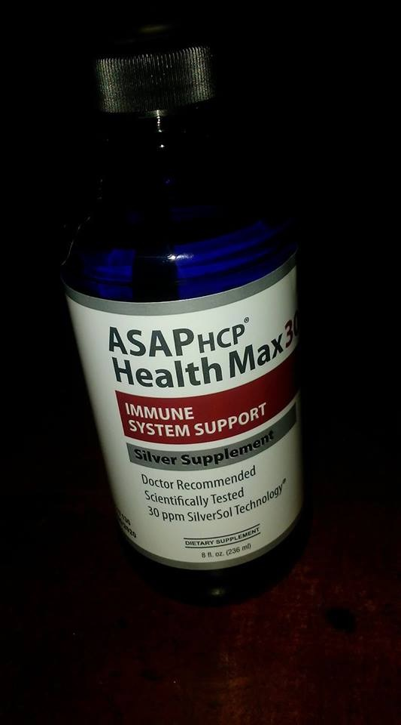
We Have Plenty of Silver Biotics in Stock!!
The Silver we sell is not your typical colloidal or sovereign silver. The silver has a special patent on it by Dr Pederson who has a government case study, patent and approval that it can eradicate viruses, bacterias, fungi and more. We have done our homework here at Bodhi Glyphix, and only sell what works. Dr. Perderson's studies show how it has helped with MRSA, SARS, Swine, Bird Flu, Anthrax and more....The 8 oz 10 ppm is $20 and 16 oz. 30 ppm is $38, prices are the same as last year. We do have new pick up dates, only on Tuesdays and Thursdays. So put your emails in the day before or of for the pick up. Our pick up box is located outside my house, by the side door in a small box. You may leave cash or a check only. If you are in for a health consultation or a yoga class you may purchase with cash, check or credit card.

_____________________________________________________________________
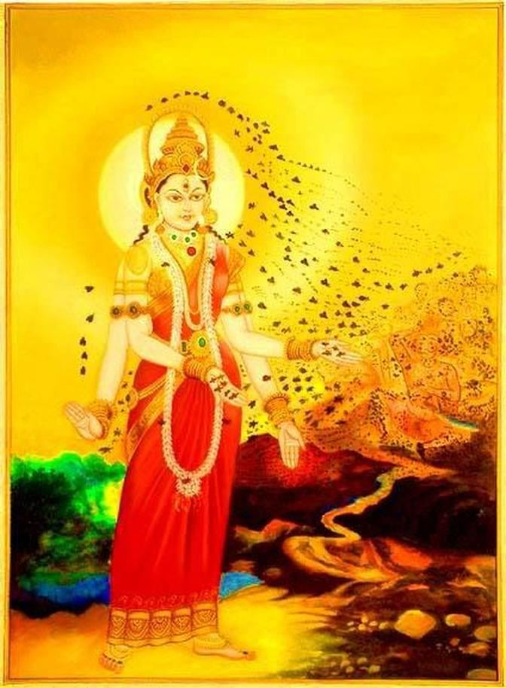
Do you hum??? Did you know that it can strengthen your immune system? You don't have to chant Om. Just Hummmmmmmm. A gentle hum stimulates your vagus nerve, that tree of life in the center of the garden of your body,

Your Hum, if you let it, sinks down and connects to the holy Name, the Mantra, the river of sound that sang the galaxies from silence. Your Hum is the song of Brahmari the bee Goddess. Let it vibrate through your skull, soothing your hypothalamus, opening the almond fragrance of your amygdala, lighting the chandelier of your pituitary in the ballroom at the center of your brain, polishing the blue pineal pearl whose arrow of Shakti will open the eye in your forehead.

Let all your cells make golden honey of the Hum dripping down the back of your throat into the cavernous temple of your chest, flowing into the grail that sits on the alter of your breastbone. Hum stars through your bellybutton. Hum sap through your root, humyoni humballs hummoonlight into your seeds, hum down the amphibian caverns of the earth where unborn suns sleep. Hum.

___________________________________________________________________________
YOQI returns!!
_____________________________________________________________________________________
YOGA NIDRA Meditation
Please join Yogini Rose for this VERY special mediation~ YN opens up doorways, releases blockages, it heals every organ, bone, muscle etc, it goes DEEP in to ALL levels of consciousness, releasing scars from traumas & abuses we have suffered from in this lifetime and more. Your YN takes you through the veils of life, afterlife, and previous lifetimes. We experience time travel, astro projection and it's also trippy! YN has an emphasis on health and healing where habitual thinking and thought patterns are reduced or eliminated. It also helps with insomnia and stress reduction and brings an incredible calmness, quietness, clarity and is one of the deepest of all meditations.

This meditation has a special emphasis on health and healing where habitual thinking and thought patterns are reduced or eliminated and it also helps with insomnia and stress reduction. It also brings an incredible calmness, quietness, clarity and is one of the deepest of all meditations. Yoga Nidra means Yogic Sleep and is a state of conscious Deep Sleep. In this Meditation, you remain in the Waking state of consciousness, and gently focus the mind, while allowing thought patterns, emotions, sensations, and images to arise and go on. However, in this meditation, you leave the Waking state, go past the Dreaming state, and go to Deep Sleep, yet remain awake. While Yoga Nidra is a state that is very relaxing, it is also used by Yogis to purify the Samskaras (negative energy & thought patterns). YN is also powerful tool for manifesting. It’s also great for insomniacs and those who suffer with PTSD.

The next class is being held on Monday September 15th at 7:30 PM at our studio (click here for directions). The class lasts about an hour. The fee is $13 and it is sold out. Many of you have pre-paid for April’s class. If you cannot make it, we can move you to November’s Yoga Nidra. Class size will be smaller with the new covid guidelines. The class is sold out~ give us some feed back if you’d like to see this great meditation twice a month!
http://www.bodyglyphix.com/upcomingclassesevents.html
_______________________________________________________________________________________
SUMMER YOGA SCHEDULE
Times | Mon | Tue | Wed | Thu | Fri
9:30 am | Mystical  Vinyasa  Flow |  | Gentle  Healing  Yoga |  | Mystical  Vinyasa  Flow
10:00 am
6:10 pm |  | Mystical  Vinyasa  Flow |  | Mystical  Vinyasa  Flow
Mystical Vinyasa Flow A nice blend of Hatha & Integrative Yoga, Pilates, Somatics, fused with Reiki, blended with the wisdom of the cosmos & mysticism of Gaia ~ geared to participants needs
Gentle Healing Yoga Gentle, healing Yoga- Yoga Therapy, Somatics and Energy Medicine Yoga fused with Reiki, blended with blended with the wisdom of the cosmos & mysticism of Gaia ~ geared to participants needs
Outdoor Yoga Saturdays only! weather Pending ~ Mystical Vinyasa Flow beneath the trees
Yoga Nidra The deepest- most healing meditation on the planet- the 1st Monday of the month at 7:30 PM
Life Goes Om Free Yoga Classes to anyone with Cancer or a life threatening disease
Class Prices $13 drop in fee or punch card fees- 8 classes $88 or 16 classes for $155
Yoga for Sports Yoga for Golfers, Runners or Snow- Sports $75 per hour
Yoga Therapy, Chakra Toning or Private Yoga by appointment $75 per hour (click here for directions)

PROUDLY SERVING OUR COMMUNITY
we're here to provide exceptional service
In alignment with our values here at Body Glyphix, we pride ourselves in offering an exceptional customer experience. Body Glyphix was established in 1984 by Rose and to this day is a heart-based business run by a female spiritual entrepreneur.
The Bodhi Glyphix Studio
Rose Czyrny
12377 Big Tree Road, East Aurora, NY 14052
email: bodyglyp@msn.com
website: www.bodyglyphix.com
phone: 716.652.7805

