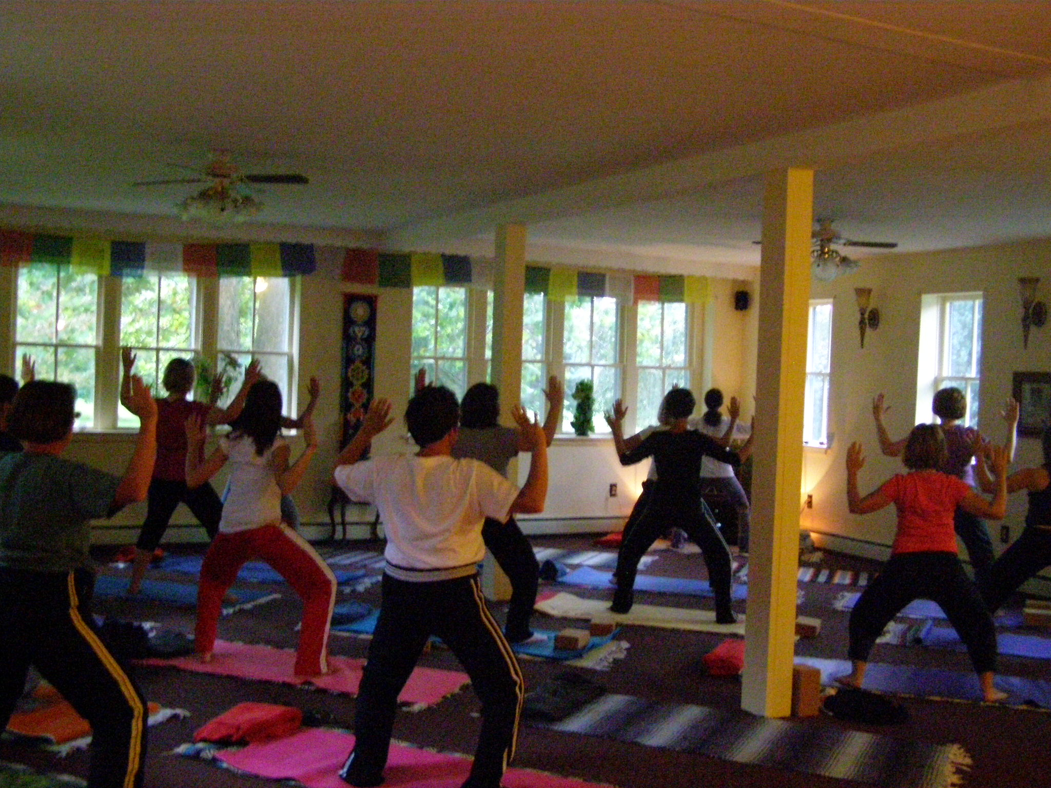
We begin class by sitting either cross legged or legs extended- it’s called Sukanasana (Easy Sit Pose). Rose or Carl have you pull your “sit bones” (bones located in the bottom of your butt!!) underneath your heart and find your breath. To practice safe Yoga- we begin to roll out from head to toe. This is an “ancient technique” to loosen up major joints and muscles to prevent injury is called Somatics~ Supygrin in Sanskrit. Rhythmic movement is next and before you know it- we are fluidly moving into easier stretches. We then “Rag Doll” up and get into standing postures (Asanas). Rose teach us where our emotions live- did you know that every part of your body has an emotional connection?? Now I know how to release negative energy! My cell phone and my negative sister are most of my problems! The standing postures increase bone density and strengthen our muscles! Sometimes if we ask- it can become cardiovascular. Or should someone come in with a sinus headache- Rose will run us through the right asana to release it! Downward we go into a good hip opener, which is done in every class. My favorite is “Eye of the Needle” which is great for golfers!! We always work the abdominals and core- all postures are done so you can modify them. Then we wind down into gentle stretching and they will pick a “Chakra” (Rose is sn Intuitive) intuitively. Chanting the Mantra to work the Chakra and Rose sometimes walks around the room tuning our Chakras as we prepare for meditation. Rose will use 100% authentic essential oils, anointing a Chakra. We do mostly guided rather than concentrated meditations- they are much more fun. We end our practice by coming back to where we started “Sukanasana” easy sit pose. An hour and 20 minutes or more later, I feel complete- stretched, toned, strengthened, de-stressed and detoxed emotionally, spiritually and physically. We do love the philosophy that is intertwined in the Asanas. As we love being part of such a beautiful and spiritual practice here at Body Glyphix!

Written by a Glyphix Yogini

