November 22nd, 2022 Issue #206 The Iris The Bodhi Glyphix Studio

Greetings!
Happy Thanksgiving from the Bodhi Glyphix Studio!! Please enjoy our latest newsletter! November is the month of gratitude (let’s open the front door of our Heart Chakras) as we share this time of “thankfulness” with friends and family. It’s also a time to remember our ancestors who came to this land and endured great hardship for us. We all have so much to be thankful for. I would like to express our gratitude to you for your support and commitment to a healthy, active sustainable lifestyle. You’re the reason we have been able to make a difference in the community and it’s for you that we strive to find new and innovative solutions to help you with your wellness goals.

“Travel light, live light, be the light & Spread the light”

Inclement Weather~ Studio Closings
As we get into winter months, living in Western NY often brings weather with hazardous travel conditions. When the weather is inclement, and you are wondering if we are closed, if our internet/phone is up and running, you will receive an email. If we do not have a phone/internet connection, check channel 7 and 2 for closing status. We would like you to be safe, when in doubt look for that email, or check Channel 7 or 2. Route 20A is kept clear, but look for our closing status, stay home and find the comfort in stillness, meditate or do some Yoga.
With Covid closings, I will send a notification email out to all. Lets keep positive thoughts on this! Thoughts become things. Keep positive thoughts 😊
______________________________________________________________________________________
MOXIBUSTION~ The Alternative to the Flu Shot
Exclusively at our Studio
This is the 16th year our humble Studio has offered this little known modality. I believe we are the only Studio in all of upstate NY to offer this technique. Moxibustion is a homeopathic remedy using Artemis Vulgaris which is used as a warming agent of the meridian associated with the immune, effective against ALL strains of influenza (except- the stomach flu which is not a true flu). Our effectiveness against all influenza is around 99%. It is a 2-minute procedure. It has been documented that this year’s medicinal Flu Vaccine is what’s left over from last year, the drift collaborated from last year’s influenza. Educated people know that the strains that affect us morph/change every 10 days. You cannot use the drift from last year to prevent this year’s viruses! Viruses evolve/morph every 10 days- constantly changing.

The fee for this exclusive procedure is $20- we do have great family and group discounts. From newborn babies to seniors- this technique is for everyone. We can come to your office or your home as well. For more information or to schedule an appointment call or email Rose. For additional suggestions- please also see the article below for Cold & Flu Prevention.
How does moxibustion work? Does it hurt?
There are two types of moxibustion: direct and indirect. In direct moxibustion, a small, cone-shaped amount of moxa is placed on top of an acupuncture point and burned. This type of moxibustion is further categorized into two types: scarring and non-scarring. With scarring moxibustion, the moxa is placed on a point, ignited, and allowed to remain onto the point until it burns out completely. This may lead to localized scarring, blisters and scarring after healing. With non-scarring moxibustion, the moxa is placed on the point and lit, but is extinguished or removed before it burns the skin. The patient will experience a pleasant heating sensation that penetrates deep into the skin, but should not experience any pain, blistering or scarring unless the moxa is left in place for too long. We do NOT use either of these techniques.
Indirect moxibustion is currently the more popular form of care because there is a much lower risk of pain or burning. In indirect moxibustion, a practitioner lights one end of a moxa stick, roughly the shape and size of a cigar, and holds it close to the area being treated for several minutes until the area turns red. Another form of indirect moxibustion uses both acupuncture needles and moxa. A needle is inserted into an acupoint and retained. The tip of the needle is then wrapped in moxa and ignited, generating heat to the point and the surrounding area. After the desired effect is achieved, the moxa is extinguished and the needle(s) removed. We do NOT use needles for this- just an indirect warming of your skin on the appropriate meridian.
What is moxibustion used for?
In traditional Chinese medicine, moxibustion is used on people who have a cold or stagnant condition. The burning of moxa is believed to expel cold and warm the meridians, which leads to smoother flow of blood and qi. In Western medicine, moxibustion has successfully been used to turn breech babies into a normal head-down position prior to childbirth. A landmark study published in the Journal of the American Medical Association in 1998 found that up to 75% of women suffering from breech presentations before childbirth had fetuses that rotated to the normal position after receiving moxibustion at an acupuncture point on the Bladder meridian. Other studies have shown that moxibustion increases the movement of the fetus in pregnant women, and may reduce the symptoms of menstrual cramps when used in conjunction with traditional acupuncture. Moxibustion is also used for many other purposes in conjunction with acupressure and acupuncture. It was discovered that the clients who received this application did not get influenza 40 years ago and forward.
At our Studio we use indirect moxibustion (without needles) to warm the skin and the meridians directly responding to the immune. The technique is quick and virtually painless. We also recommend taking Vitamin D3 supplements, Silver Sol (we carry this priced way below suggested retail price), washing hands frequently and avoid touching your face. Set up your appointment today. It literally takes a minute!
_________________________________________________________________________
Help with Sinus Problems!

Most of us living in WNY have them- whether we like it or not. You know- Sinus infections, head colds- whatever you want to call it. The first line of defense should you feel a head cold or sinuses coming on is to avoid sugar, wheat, dairy and alcohol. Sugar, wheat and alcohol make viruses and bacteria multiply. Dairy creates mucous and congestion. A 24 hour fast is highly recommended- most of us can safely fast for 24 hours, water/herbal teas/unsweetened juice, or bone broth fast. Make sure that you are hydrated~ 6-8 glasses of filtered water. Doing a Colon and Liver Detox (we carry a good supply at our Studio) extremely important- even better if you can do this during a fast. Following this protocol- you just may catch it just before it gets out of hand. Nature’s Sunshine’s Seasonal Allergies is an effective supplement to heal the respiratory track. Read the article below to see more on this amazing product.
If this doesn’t work and you do get sick- I have been VERY successful helping my clients with our Silver Biotics. This is not the same as Colloidal Silver. It is suspended in a solution making it much lighter and more effective at killing bacteria, fungi and viruses. We always have it in stock at the Studio. I recommend 1 tsp/tblsp 3 times per day orally. Take the Silver Biotics nasally too. We now carry a triple strength Silver that is necessary to get the nasty virus that is going around. Whether you use a little in your Neti Pot or dropper or just sniff it from the cap. It can go in your humidifier or nebulizer also. In tough cases- I like to add either Myrrh, Goldenseal, Oregano, Grapefruit Seed Extract or Olive Leaf (orally) - also sold in our Studio. It may sound cliché- but we only sell the best, if we sell products that do not work- you will not come back or recommend me. Should you get sick- give us call or an email. We have what you need during cold and flu season. We have a large selection of detoxes at our Studio also.
I have made it a practice, in the 44 years that I have been in business and helping people with their wellness goals- I only endorse products, services and programs that historically work, that I truly believe in, from providers I know and trust. That have also been tested, case studied or a stamp of approval from the top Naturopathic doctors or holistic practitioners in the US. Don’t forget to neti pot!!
_________________________________________________________________________
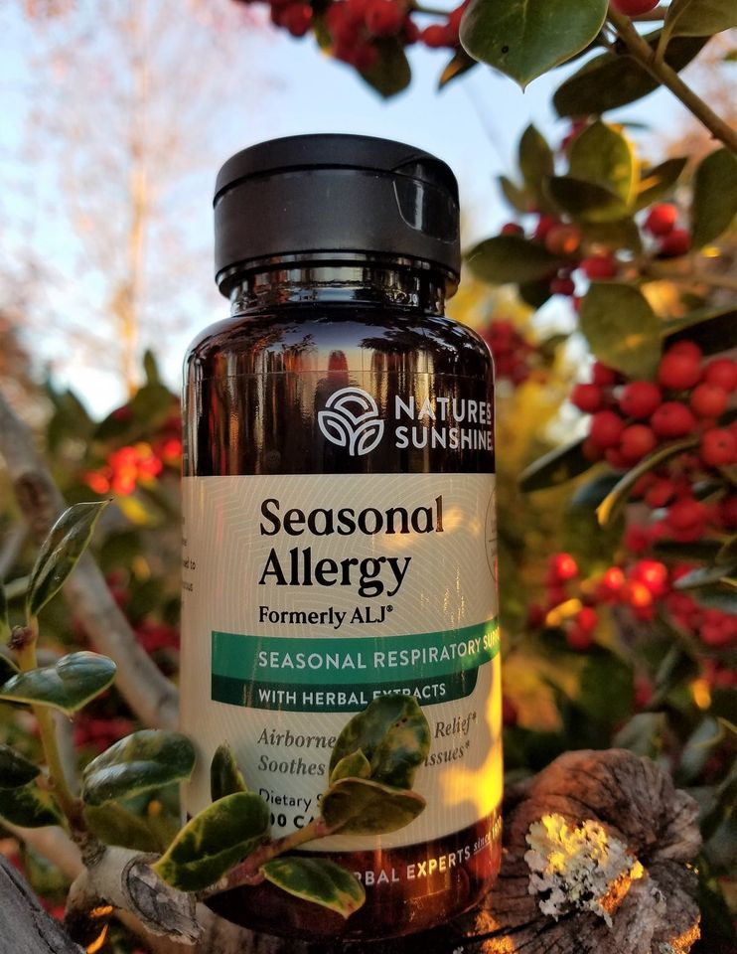
As the first waves of cold winter weather sets in, the winter berries begin to ripen and the last of the Fall leaves let go. A chill goes through my body when I step outside to find the temperature has dropped significantly overnight. I return inside to dig through my drawers for sweaters and my heavy socks. Now that I am nice and warm, I grab a few Allergy Lung formula (ALJ) before leaving the house – this is my cold weather friend.
Allergy lung formula (formally called ALJ) has been a staple in my herbal medicine cabinet for more than 25 years. Most people think of using this formula to help their body deal with allergens in the air, and I am no exception. I keep Allergy Lung formula on my counter all during the spring blooming season. However, upon studying the herbs in the formula, I discovered that this is a wonderful formula for boosting the body’s defenses when cold weather sets in.
The first herb in the Allergy Lung formula is Boneset –this herb gets its name directly from its traditional use of helping the body fight off the flu. The flu’s original name was “break-bone” fever because of the achy bones that came with the onset of the symptoms. The herb Boneset was found to help get rid of the aches and pains associated with the flu. Boneset has traditionally been used to help the body overcome cold symptoms, to induce sweating and relieve achy joints, and fever. The herb Boneset also has expectorant properties which help to loosen and dissolves mucus – which is why it is so helpful with spring allergy symptoms.
The next 3 herbs in the formula are interesting: Fennel, fenugreek and horseradish which are all spicy aromatic herbs, which have warming properties in the body. These herbs act as expectorants to loosen and dissolve mucus. In addition, these herbs help to improve digestion and may help break up gas and relax intestinal spasms. The herb fenugreek also helps to soothe irritated tissues in the sinus and digestive tract. Since the body’s response to sudden cold weather tends to create a lot of mucus, these warming spicy herbs are a real blessing.
An old-fashioned natural remedy for sinus congestion was to recommend taking a1/4 tsp. spoonful of fresh horseradish and hold it on your tongue until all the taste was gone. It would immediately start cutting the mucus loose form the sinus to drain down the throat. This would help clear the pressure in the sinus and clear the infection. I do this when I need some quick relief; but for those who do not think this sounds appealing, it is nice to be able to get the benefits of the horseradish in the Allergy Lung formula, without the taste.
The last herb in the formula is Mullein – this is a cooling mucilaginous herb which means it is soothing to mucus membranes. Mullein also has natural expectorant properties like the other herbs in the formula. The cooling effect of the mullein helps to calm the energy of the other spicier herbs to bring balance to the formula.
Here's to a healthy winter season,
Blessings, Valerie Greguire, CH, Natural Health Consultant
___________________________________________________________________________________
Depression and the Holidays
Connecting to your Heart Center
|
There is a concept in Chinese Medicine called Shen. Your Shen resides in your heart, it can be described as the part of you which connects with your heart and spirit, or higher self. When Shen is depleted, we feel depressed and lack inspiration. It becomes hard to accomplish even simple tasks, because we don’t seem to care about anything. When your Shen is depleted, you feel disconnected from life, there may be an emptiness in your eyes, and a lack of peace in your life. You may suffer from sleep disturbances, patterns of stress, anxiety, or agitation. Imbalances of Shen can result in mental cloudiness, loss of memory and a lack of ability to maintain focus.
We connect with our Shen though our heart center. Think of the expression “follow your heart” verses being led by your logical mind. Our Shen gets depleted when we push ourselves to a point where we are just going through the motions of life. We deplete our Shen when we do not take time to go into our heart to rekindle our Spirit, connect with our Creator and quiet our mind. In addition, anything that “upsets the heart” can deplete Shen. Trauma, arguments, emotional struggles, or overuse of alcohol and drugs – even prescription drugs, if they cause you to feel disconnected from yourself.
In addition, you may notice the following:
Life feels off balance; your personality does not fit the life you are living.
There is a lack of inspiration and meaning to your life.
You feel like you have lost yourself, don’t know who you really are anymore. You have no sense of purpose.
You may have a lot of things going on around you, but you can’t find your center, so this leads to anxiety, restlessness, and eventually, fatigue.
You can no longer tell what is truly right for you.
Chinese Mood Elevator formula – is a combination of herbs traditionally used in Chinese medicine to help restore your connection with Shen to help increase vitality and promote a greater sense of well-being. This formula also helps to “calm the spirit and quiet the heart”. The herbs in this formula also work to gently cleanse the liver which helps to improve the flow of “Chi” (life force energy) throughout the body, which helps to lift the moods. The herbs in this formula promote healthy digestive functions, help the body to release pain and inflammation.

As your connection with Shen and the flow of Chi (life force energy) returns you will feel a shift in your perspective. It’s like the “birds are singing” again. Life begins to have more meaning and purpose, you feel whole, more complete. Your sleep is more restful. As you build your Shen you will focus more on the things that are important to you. You have a desire to align your life with your heart’s inner callings, you seek your Soul purpose. As you build your Shen your intuition activates, you have greater insights on your life choices and directions. Your eyes will have a brightness return to them and your mind will become clearer.
Blessings, Valerie (a fellow holistic practitioner)
I have used this excellent Nature’s Sunshine product to get me through a period this year of heavy grief, it can help with anxiety, depression, and many issues of the heart. I used Mood Elevator TCM, a concentrated version, taking less. Interested in ordering this? Make sure you are taking D3 also! 5000 IU’ daily, the main reason we suffer with the above. To order~ call them 1-800-223-8225 and tell them Body Glyphix (my acct # 9191) should be your sponsor, for my wholesale prices!! Rose
_______________________________________________________________________________________

What’s on Their/Your Holiday list?

It’s time to think about the upcoming Holidays. What’s on your holiday list? Perhaps a Yoga Pass Card? A Body, Mind & Soul Consultation? Or maybe you are thinking for someone that has everything? A private Yoga Session? Clearing their/your house or business of negative energies? Chakra Toning Session with Crystals? Or our products? When they ask this season- tell them what you want! Or maybe there’s someone that could benefit with the gift of health. We have gift certificates for any dollar amount! You may purchase them on my secure website www.bodyglyphix.com/giftcertificates.com or pick them up at the Studio~ anytime……
_______________________________________________________________________________________
It's Flea & Tick Season
This is the worst year ever for ticks! Please keep Ledum in your medicine cabinet for your pets and yourself. This time of year the little beasts are looking for a warm host. Here’s what to take when you find a tick….
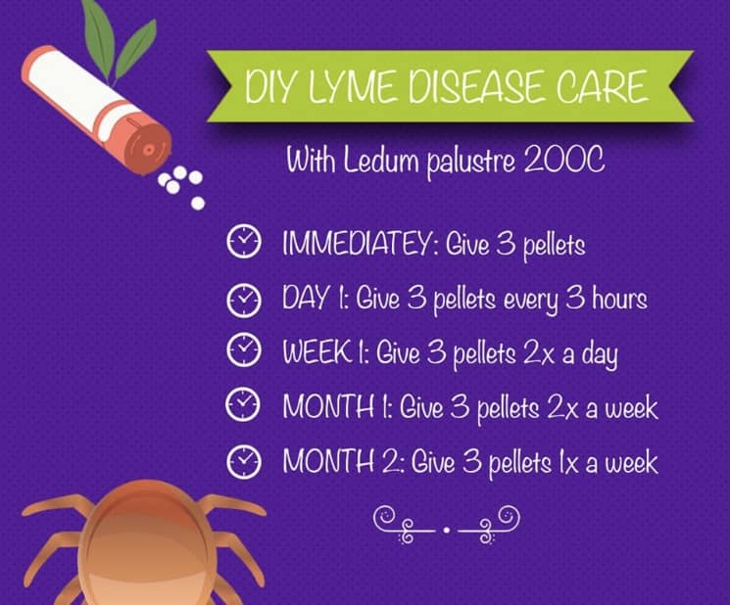
_______________________________________________________________________________________
Solstice Sound Healing at our Studio
Saturday December 17th
Please join Todd Morgan for a sound healing Have you ever wondered why it is called a “sound bath”? And can it actually “heal” anything? Join us in learning another step toward self-healing in a one-hour rejuvenating crystal singing bowl sound bath meditation. This ancient wellness practice uses vibrations to guide you into a state of deep relaxation in order to align the subconscious with the healing intent. Todd provides a comforting and healing space, using crystal singing bowls, Himalayan bowls, gongs, Koshi chimes, shamanic drum, a crystal pyramid, and tuning forks. The deep sound of the first gong initiates and washes the room with a lingering, far reaching sound that gently bathes your body-mind-spirit. The sounds will begin to flow through you; vibrating every cell in your body. Every sound immersion is unique and speaks to each person in an individual way. In general, participants experience a deep relaxation response (with or without falling asleep), as well as feeling emotional, mental and spiritual responses. When the session comes to a close, you gently transition back to here and now in a new state of reflection, insight, or at the very least, a lowered blood pressure, a slowed-down mind, and a better understanding of sound healing and its effects. Bring your mat/cushion, pillow, a blanket, and a knee bolster if you’d like. Please keep your body hydrated beforehand.
Cost is $25, pre-payment registers you for this exciting and innovative session. Reserve your spot! I will see you all there.
To pre-pay and pre-register go to:
Venmo @Todd-Morgan-16
PayPal Tmorgo11@gmail.com
___________________________________________________________________________
Yoga Nidra~ Meditation
Please join Yogini Rose for this VERY special mediation~ YN opens up doorways, releases blockages, it heals every organ, bone, muscle etc, it goes DEEP in to ALL levels of consciousness, releasing scars from traumas & abuses we have suffered from in this lifetime and more. Your YN takes you through the veils of life, afterlife, and previous lifetimes. We experience time travel, astral projection and it's also trippy! YN has an emphasis on health and healing where habitual thinking and thought patterns are reduced or eliminated. It also helps with insomnia and stress reduction and brings an incredible calmness, quietness, clarity and is one of the deepest of all meditations.
This meditation has a special emphasis on health and healing where habitual thinking and thought patterns are reduced or eliminated and it also helps with insomnia and stress reduction. It also brings an incredible calmness, quietness, clarity and is one of the deepest of all meditations. Yoga Nidra means Yogic Sleep and is a state of conscious Deep Sleep. In this Meditation, you remain in the Waking state of consciousness, and gently focus the mind, while allowing thought patterns, emotions, sensations, and images to arise and go on. However, in this meditation, you leave the Waking state, go past the Dreaming state, and go to Deep Sleep, yet remain awake. While Yoga Nidra is a state that is very relaxing, it is also used by Yogis to purify the Samskaras (negative energy & thought patterns). YN is also powerful tool for manifesting. It’s also great for insomniacs and those who suffer with PTSD.

The class is being held on Monday December 5th at 7:30 PM at our studio (click here for directions). The class lasts about 50 minutes. The fee is $13 at the studio. Pre-pay & registration is a must- to pre-register go to http://www.bodyglyphix.com/upcomingclassesevents.html if the pay link is removed, the class is full. Paying for the meditation on line is $14 to cover our costs for the transaction.

WINTER YOGA SCHEDULE
Times | Mon | Tue | Wed | Thu | Fri | Sat
9:30 am | Mystical  Vinyasa  Flow |  | Gentle  Healing  Yoga |  | Mystical Vinyasa  Flow
6:10 pm |  | Mystical Vinyasa  Flow |  | Mystical  Vinyasa  Flow

Mystical Vinyasa Flow A nice blend of Hatha, Integrative, Pilates & Foot Reflexology fused with Reiki, blended with the wisdom of the cosmos & mysticism of Gaia ~ geared to participants needs
Mystical Vinyasa Flow A nice blend of Hatha & Integrative Yoga, Pilates, Somatics, fused with Reiki, blended with the wisdom of the cosmos & mysticism of Gaia ~ geared to participants needs
Gentle Healing Yoga Gentle, healing Yoga- Yoga Therapy, Somatics and Energy Medicine Yoga fused with Reiki, blended with blended with the wisdom of the cosmos & mysticism of Gaia ~ geared to participants needs
Life Goes Om Free Yoga Classes to anyone with Cancer or a life threatening disease
Class Prices $13 drop in fee or punch card fees- 8 classes $88 or 16 classes for $155
Yoga for Sports Yoga for Golfers, Runners or Snow- Sports $85 per hour
Yoga Therapy, Chakra Toning or Private Yoga by appointment $85 per hour

"Wishing you Heaven in your heart, starlight in your soul and miracles in your life in these changing times" The vibrational rate of our planet is quickening- the vibrations have a dominant masculine force Our bodies must make the vibrational change with the planet.
Yoga and meditation are very helpful with this transition….

The Bodhi Glyphix Studio
Rose Czyrny
12377 Big Tree Road, East Aurora, NY 14052
email: bodyglyp@msn.com
website: www.bodyglyphix.com
716.652.7805

