May 27th, 2021 Issue #200 The Iris The Bodhi Glyphix Studio

Greetings!

Thank you for opening our newsletter. If you no longer wish to receive our newsletters, please scroll down and choose the unsubscribe button. We are currently exiting Mercury Retrograde as of June 3rd the planet will go direct. The planet of communication Will appear to be going Correct down its path around the sun. Look for a meteor shower May 30/31st https://www.farmersalmanac.com/one-time-only-rare-memorial-day-meteor-shower?fbclid=IwAR2-YWiLVuWlAt61rvyDP3xKP3T2UibHRiw_4THHjDwOf5zFvxnybpINV8w
______________________________________________________________________________________________
Our studio will be closed Friday, July 1st Through Friday, July 15th So if you need supplements Any advice? Please reach out to us before then. Look for An email or posting On our sound bath that’s happening In a few weeks As Todd Morgan Brings us His healing sounds.
__________________________________________________________________________________________________

The Medicine Way~ A Triune to Ancient Medicine



The lavender labyrinth is open for grounding, clearing, manifesting
A labyrinth is an ancient symbol that relates to wholeness. It combines the imagery of the circle and the spiral into a meandering but purposeful path. The Labyrinth represents a journey to our own center and back again out into the world. As you walk in and out of it, you will find yourself refreshed, grounded and cleansed, body, mind & soul. Labyrinths have been found in temples, pyramids, and scattered around our planet. Many ancient cultures valued the healing properties of the spiral.
Come walk our labyrinth, before or after Yoga or a Consultation- or anytime that you are in the neighborhood. The Labyrinth is located just behind our Studio. It is enhanced with organic Lavender and native Turtle Rocks which coincide with the 4 cardinal points. Feel the energies! Smell the relaxing lavender! Connect with nature! Later in the summer, watch a moon flower open as the sun sets.
Begin in the entrance located in the North (earth). Enter with a clear mind as you begin to walk counter-clockwise (releasing negative energy). Breathe in the lavender- allow it to relax your body, mind & soul. The path will change and you will move clockwise (strengthening your convictions). Feel the energies move through you as you spiral into the center. When you reach the center you will be facing east, invoking the fire element. Pick or choose an intention (manifesting) here. To raise your energies, reach down and touch the Key Stone. This rock was found in our creek bed, and over time the water has spun it and shaped it almost perfectly round! It has many thousands of years of energy (prana) in it for you to access! Stop by the Wishing Well to manifest intentions and don’t forget to visit the frogs in our Buddha Fountain.

____________________________________________________________________________________

Lodestone Pool

On March 27th, 2020~ a natural plunge pool was born on our property. It was created with love by Senpai Gary Marchuk with all natural elements. It may be used for healing purposes such as meditation, healing and reflecting.

Lodestones are naturally occurring in New York having magnetic, magical, healing powers. Said to bring luck, love, prosperity and abundance. It will work with you to attract all that you most desire, including people, things, situations, opportunities, and the like.

It’s a naturally magnetic stone that has an extraordinary capacity to balance the hemispheres in your brain. It’s a stone that will help you bring whatever you want most into your life. Its magnetic attributes make it a very potent and spiritual grounding stone as well.

Lodestone’s vibrations will invite experiences and opportunities in your present situation that are necessary for you to go through. The Lodestone has a very strong vibration, and you will find that the vibrations are very effective when it comes to balancing your aura. It’s a powerful stone that will bring the meridians and Chakras into alignment.
_______________________________________________________________________________________

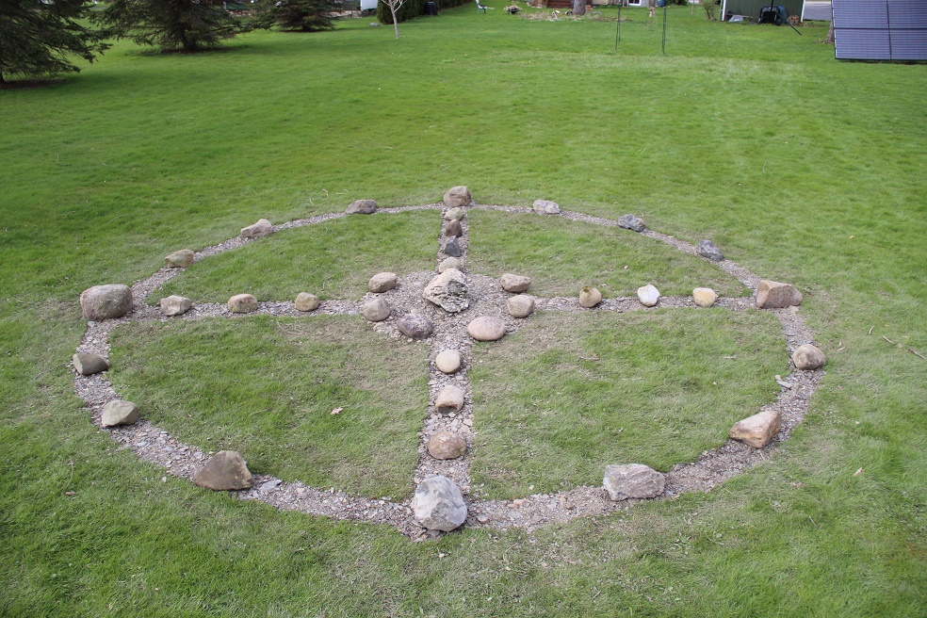

The Medicine Wheel
The Medicine Wheel~ the latest addition to the property situates triangulated with the Lavender Labyrinth and the Lodestone Pool. The “triangulation” of the three has many meanings.
Symbolic meaning of triangle in Sacred Geometry….triune,
birth - life - death,
body - mind - soul,
father - mother - child,
sky - earth - lower world,
Sun: life - heat - light.
The medicine wheel sometimes known as the Sacred Hoop, ha been used by generations of various Native American Tribes for health and healing. It embodies the Four Directions, as well as Father Sky, Mother Earth, and Spirit Tree~ all which symbolize dimensions of health and the cycles of life.

Thank You Senapi Gary for your love adding yet another piece to the Medicine Way at our Studio. T’was a very cold week in April when he built it according to the Indigenous Ways.
_______________________________________________________________________________________
Happy Father’s Day

To all of you Dads and women also- that have assumed the role of a Father. Many divorced or widowed women- assume the role and these masculine energies. Should you be looking for something different to give, or get- consider a gift of health with Yoga or a Body, Mind & Soul Consultation. We have gift certificates anytime, not just the Holidays. You may order one safely on our secure website www.bodyglyphix.com/giftcertificates.html or pick one up at the Studio.

________________________________________________________________________________________________

ACHHOOOOOOO! What’s bugging you?

What’s bugging you? Grass, oak & birch- Oh My!! They are lurking everywhere! The Pollen Count-is it Low, Medium or High? To find out if you are going to have a bad day- go to our website www.bodyglyphix.com/localpollencount.html enter your zip code and see how high the pollen count and what pollens are causing the issues.

Some of us are affected by these invaders of our respiratory track- and others are fine. When our bodies are sensitive to pollens, mold spores- it is called “environmental sensitivities or allergies.” This is usually a sign of toxicity in our bodies- heavy metals, fungus, processed foods, parasites, etc. To find out what is “Bugging You” internally creating these sensitivities externally- call us and make that appointment for a Body, Mind & http://www.bodyglyphix.com/services.html

This is allergy season- a good time to clean up your lymphatics and urinary track. Which cleanse is the right ones for you? Please call or email us for an appointment. There are many different things that you can take to alleviate allergies- but going to the root of the problem will eliminate them for good.
Nature’s Sunshine’s Histablock is a natural plant-based supplement to block histamines and ALJ a plant-based supplement to help the respiratory track. We carry them at our Studio! Or order them yourself- call 1-800-223-8225 and tell them Body Glyphix (9191) said to call or click on https://www.naturessunshine.com/?referrer=9191 to get our wholesale prices!!! And read below~ keep your histamine levels down….

______________________________________________________________________________________

10 High & Low Histamine Foods

If you’ve ever dealt with seasonal allergies/sensitivities, or you happen to have a serious food allergy, then you’ve likely heard the term “histamine” in one context or another. While histamine is directly related to allergic reactions, it’s technically a chemical in your immune system which cause an immediate inflammatory response after coming in contact with any food or drink item that your body deems a potential health threat.
It works a bit like this: imagine a peanut allergy. When you eat a peanut, histamine automatically inflames your blood vessels. This lets your body know it needs to send as many white blood cells – the kinds that attack infection – to the affected areas as possible. However, too much histamine sent at once can obviously cause a severe allergic reaction that, if not treated quickly, can cause anaphylaxis.
However, it’s also possible to have too much histamine present in your immune system – even if you’re not allergic to any food or don’t have seasonal allergies. It’s also possible to have too little histamine. Regardless of your need (more or less histamine) let’s look at ten different foods that are either high or low in histamine. This list should help you make better dietary choices, leading to a greater overall systemic health.
High – Fermented alcohol
If you enjoy a drink every now and then, it’s unlikely fermented alcohol – such as wine, champagne, and beer – will have an effect one way or another on your histamine level. However, if you consume the aforementioned beverages on a regular basis and find yourself suffering from histamine intolerance (the symptoms of which closely mimic regular allergies) then you’ll have to look into reducing your intake of fermented alcoholic products.
High – Cured meat
Bacon may feed the soul, but aside from being outrageously high in fat and sugar, cured bacon is also high in histamine. The same goes for any cured meat – that is, it’s set to “marinade” in usually sugary or savory solution before being packaged and shipped to your local grocery store – such as salami, pepperoni, lunch meats, and even hot dogs.
Red meat, such as steak or hamburger, is a better choice if you can’t live without meat but need to decrease your histamine intake.
High – Citrus
Grapefruit, oranges, lemons, and limes are all high in histamine. They’re also high in citric acid which is especially harmful for the health of your tooth enamel. While that may not seem like a big deal on the surface, if your teeth become weakened due to excessive contact with citric acid, and you develop a histamine intolerance and have too much in your body, you could end up with some serious health problems. It’s worth your time to cut out your citrus intake, for both your histamine level and your teeth.
High – Vegetables
Finally! It’s the excuse you’ve been waiting for to get you out of the nightly serving of vegetables inevitably heaped on your plate.
Well, don’t get too excited right off the bat. Not all vegetables are high in histamine. The ones that are high in histamine are avocados, eggplant, spinach, and tomatoes. Avocado and tomatoes are easily the most popular in that list – and therefore the most difficult to avoid. However, a bit of planning and research for alternate recipes (spaghetti sauce made with non-cured meat, for example) can help you get around the issue of not being able to indulge in a great seven-layer dip or your mom’s homemade salsa.
High – Fish
If you’re a big fish fan but have too much histamine in your diet, you’ll likely need to cut back. Most smoked fish is high in histamine, in addition to mackerel, mahi-mahi, tuna, anchovies, and sardines. For most people, finding fish substitutes for mahi-mahi and tuna will be difficult. However, halibut and salmon are both viable options, in addition to cod or wild-caught trout. Regardless, you don’t want to have your fish smoked. Smoking fish subjects them to a very similar treatment as we see with cured meats, which are also on the high histamine list – the list to avoid if you have any histamine problems at all.
Low – Eggs
Your breakfast of bacon and eggs isn’t quite lost! You’ll just have to cut out the bacon. Eggs are a great low-histamine food, so if you’re transitioning from a high-histamine to a low-histamine diet, you’ll be set for any of your favorite omelets or other egg-based dishes. While you need to watch what you put in your omelets – avoid the diced ham, bacon, etc. – bell peppers, cheese, and steak are viable and low-histamine additions to help spruce up your morning meal.
Low – Pure peanut butter
The peanut butter and jelly sandwich may be the most iconic sandwich ever made, and for good reason – they’re oddly satisfying. This is great news for any peanut butter lovers out there, as the pure peanut butter (nothing but crushed peanuts and a bit of sugar or oil) is a low-histamine food that some would argue tastes better than the processed version. Of course, that’s a call you’ll have to make on your own.
Low – Fresh fruit
You can still have plenty of different fruit if you need more low-histamine food in your diet. Fruits such as mangoes, pears, watermelon, kiwi, and grapes are a low-histamine go-to. This also helps balance out any lost nutrition you may have lost from cutting a bit of your vegetable intake as mentioned above.
Low – Tea
If you’re a big tea fan, you can keep on drinking! Leafy and herbal teas are low-histamine and provide some of the same antioxidants and immune-boosting effects vegetables do – without the added histamine.
Low – Fresh meat
Finally, make sure that if you’re eating meat it’s free range or organic fresh, and that your poultry is as fresh as possible.
_______________________________________________________________________________________
Rose’s Tabouli recipe
Refreshing summer salad

½ cup bulgur or quinoa (optional) tomatoes, chopped into sm cubes
2 bunches of parsley 4 tblsp. Olive Oil
½ bunch of fresh mint ½ tsp. sea salt
2 lemons juiced romaine lettuce (optional)
¼ to ½ tsp of ground pepper ½ bunch of green onions or diced onions

Soak bulgur in cold water for half an hour, or cook quinoa while you chop up ingredients or make some quinoa. Wash and use scissors to cut up the parsley and mint (very finely). Place the parsley, mint, onions and tomatoes in a bowl. Squeeze the water out of the bulgur and add it to the vegetables. Add the oil, salt, pepper and lemon juice and mix together. Taste and correct the seasonings per your taste. Eat it like a salad served with romaine, cabbage, grape leaves or stuff it in a pita. If fresh mint is not available, substitute with one tablespoon of dried mint.

Parsley is good for bladder infections (UTIs), kidney stones (nephrolithiasis), gastrointestinal (GI) disorders, constipation, diabetes, cough, asthma, and high blood pressure.
__________________________________________________________________________________
Yoga Nidra Meditation
There will be no Yoga Nidra Meditation for July as our studio will be closed. See you all in August for the most healing meditation ever.

______________________________________________________________________________________
SUMMER YOGA SCHEDULE
Times | Mon | Tue | Wed | Thu | Fri | Sat
9:30 am | Mystical  Vinyasa  Flow |  | Gentle  Healing  Yoga |  | Mystical Vinyasa  Flow
6:10 pm |  | Mystical Vinyasa  Flow |  | Mystical  Vinyasa  Flow

Mystical Vinyasa Flow A nice blend of Hatha & Integrative Yoga, Pilates, Somatics, fused with Reiki, blended with the wisdom of the cosmos & mysticism of Gaia ~ geared to participants needs
Gentle Healing Yoga Gentle, healing Yoga- Yoga Therapy, Somatics and Energy Medicine Yoga fused with Reiki, blended with blended with the wisdom of the cosmos & mysticism of Gaia ~ geared to participants needs
Yoga Nidra The deepest- most healing meditation on the planet- the 1st Monday of the month at 7:30 PM
Life Goes Om Free Yoga Classes to anyone with Cancer or a life threatening disease
Class Prices $13 drop in fee or punch card fees- 8 classes $88 or 16 classes for $155
Yoga for Sports Yoga for Golfers, Runners or Snow- Sports $85 per hour
Yoga Therapy, Chakra Toning or Private Yoga by appointment $85 per hour (click here for directions)
__________________________________________________________________________________
we're here to provide exceptional service
In alignment with our values here at the Body Glyphix Studio, we pride ourselves in offering an exceptional customer experience. Body Glyphix was established in 1984 by Rose and to this day is a heart-based business run by a female spiritual entrepreneur.
The Bodhi Glyphix Studio
Rose Czyrny
12377 Big Tree Road, East Aurora, NY 14052
email: bodyglyp@msn.com
website: www.bodyglyphix.com
phone: 716.652.7805

